**Day1: Download, Install and configure**

Download -> Install -> configure path in system environment variables

* Java

<https://download.oracle.com/java/21/archive/jdk-21.0.5_windows-x64_bin.exe>



* Git

<https://github.com/git-for-windows/git/releases/download/v2.49.0.windows.1/Git-2.49.0-64-bit.exe>

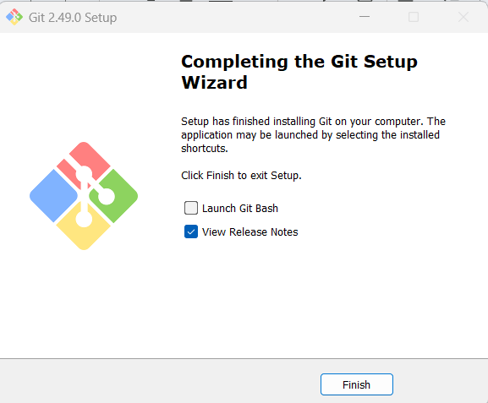

Download --> configure path in system environment variables

* Maven

<https://dlcdn.apache.org/maven/maven-3/3.9.9/binaries/apache-maven-3.9.9-bin.zip>

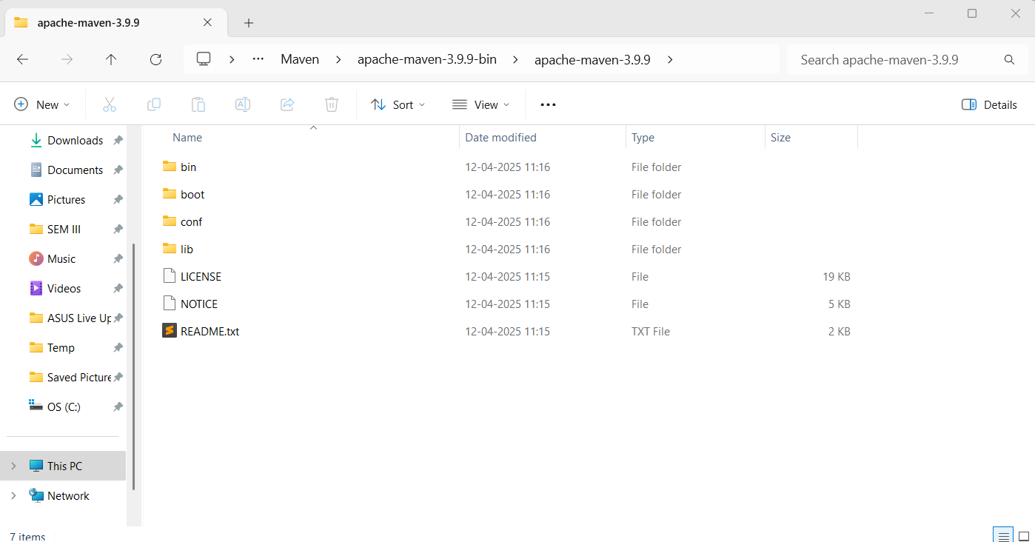

* Terraform

<https://releases.hashicorp.com/terraform/1.11.4/terraform_1.11.4_windows_386.zip>

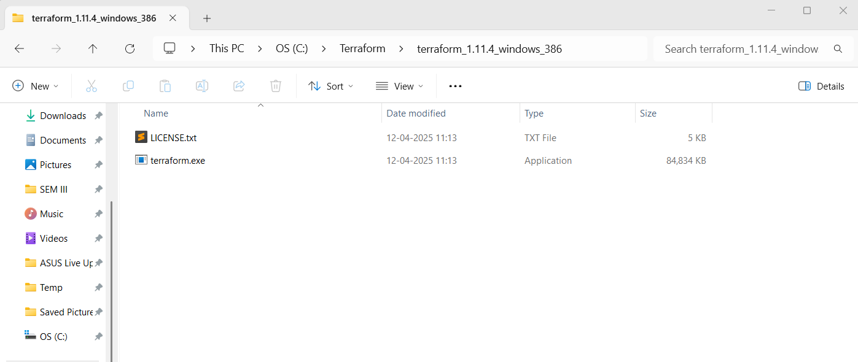

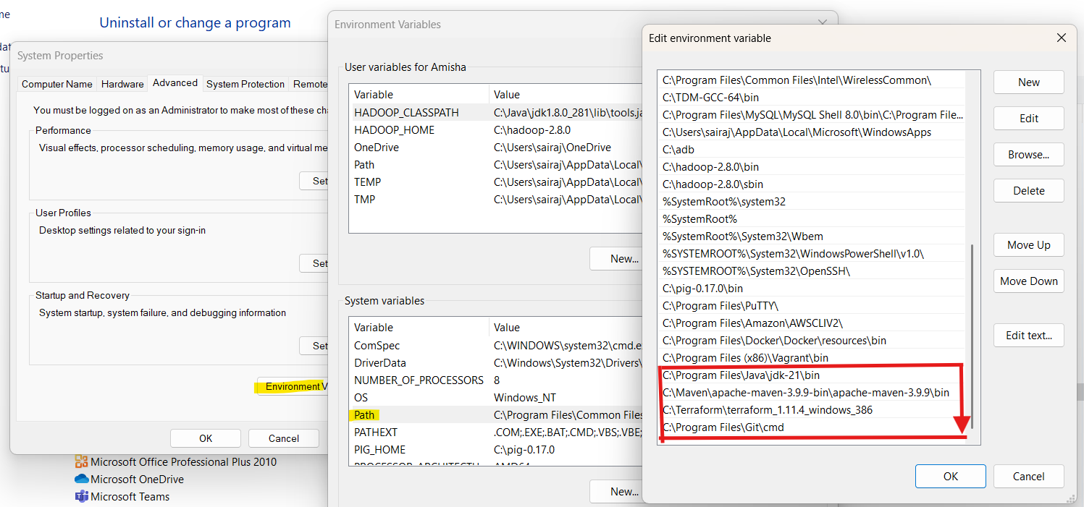

**Validate the installation:**

>java --version

>mvn --version

>git --version

>terraform --version

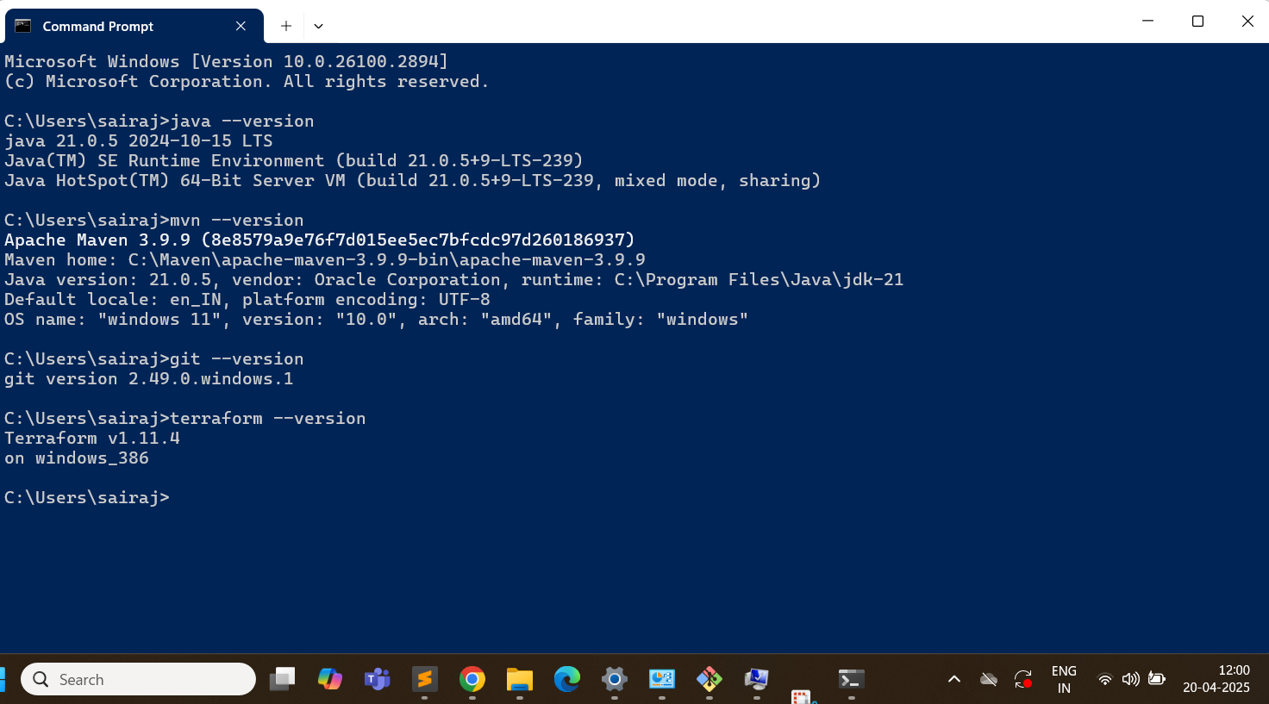

**Install IntelliJ IDEA & VSCode:**

IntelliJ IDEA Community Edition

<https://www.jetbrains.com/idea/download/?section=windows>

VSCode

<https://code.visualstudio.com/download>

**Create accounts:**

* AWS account
* Github Account
* Docker hub account

**Day3: Creating our first microservices**

Go to <https://start.spring.io/>

Select:

Project: Maven

Language: Java,

Springboot version: 3.310

Artifact name: makemytrip

Packaging: Jar

Add the dependencies: Spring Web, String Boot Actuator

Generate the zip file

Extract the zip file

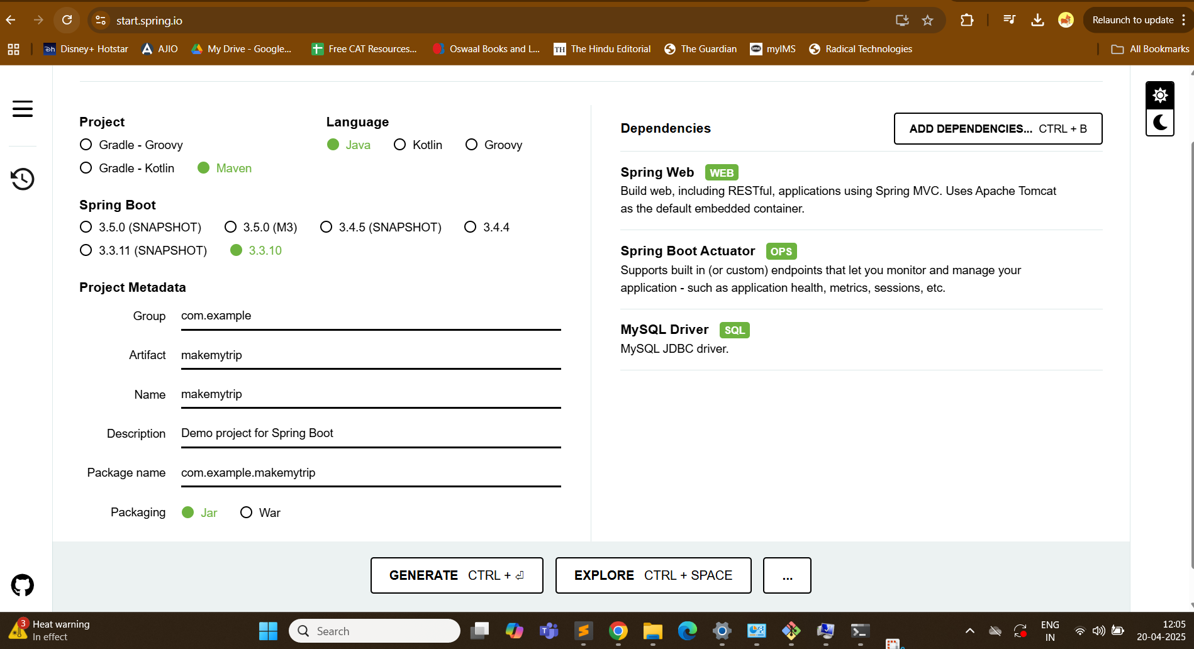

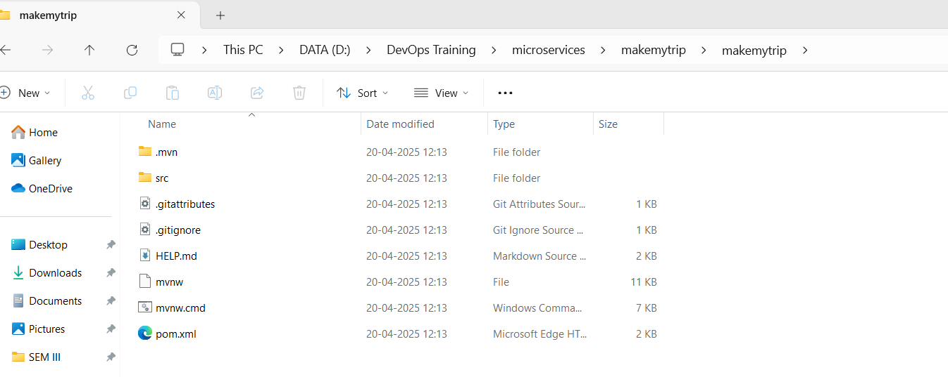

> mvn clean compile

(Creates .class file)

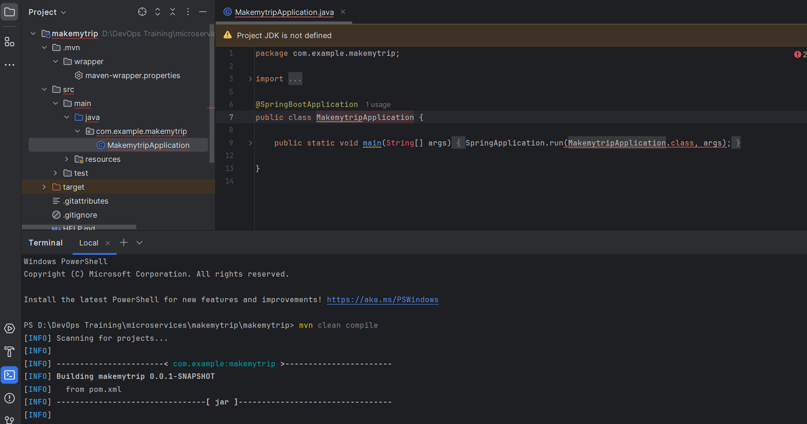

Location of .class file

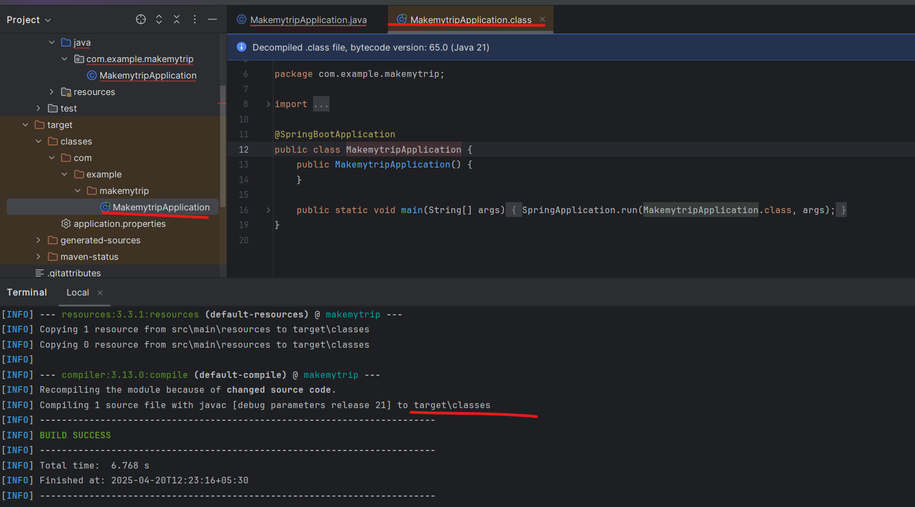

Now package:

> mvn clean package

Default package is .jar

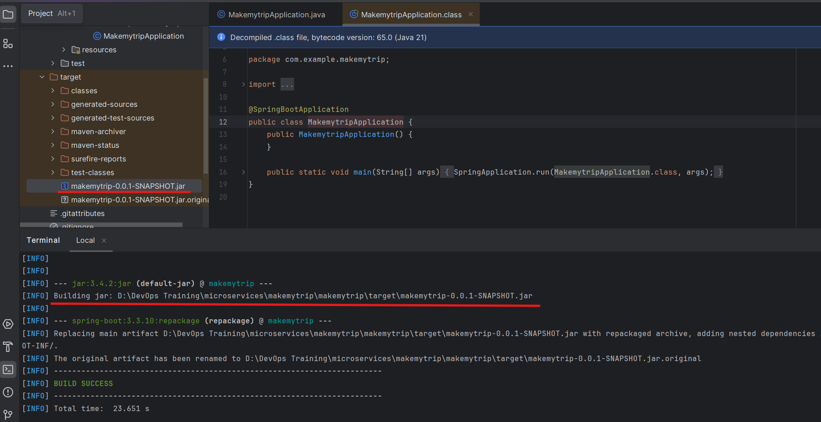

Now add a java fileRight click on java skeleton > new > java class > flights

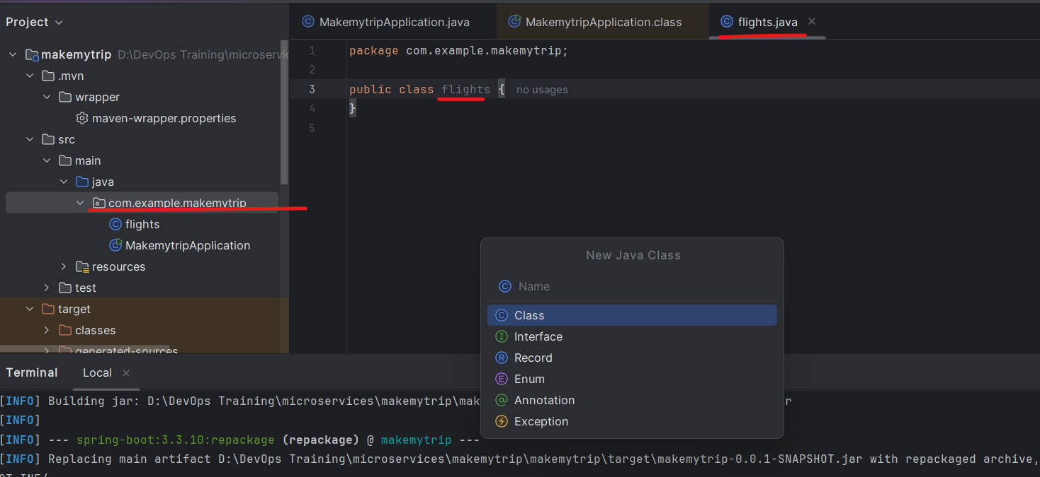

Add following to to this file flights.java:

package com.example.makemytrip;

import org.springframework.web.bind.annotation.GetMapping;

import org.springframework.web.bind.annotation.RestController;

@RestController

public class flights {

@GetMapping("/flights")

public String getData() {return "Book your FLIGHTS from Kolkata to Pune!";}

}

After ading new code - you need to compile and package it again.

> mvn clean compile

> mvn clean package

.class and .jar file is generated

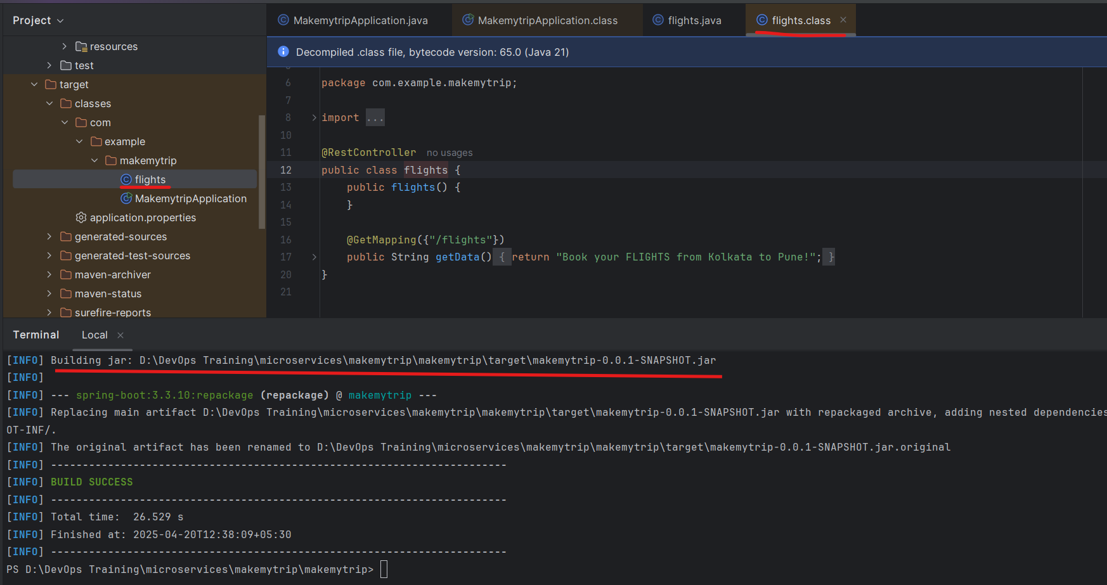

> mvn spring-boot:run

With help of this we will run the application on local system.

We can see the application is running on port 8080

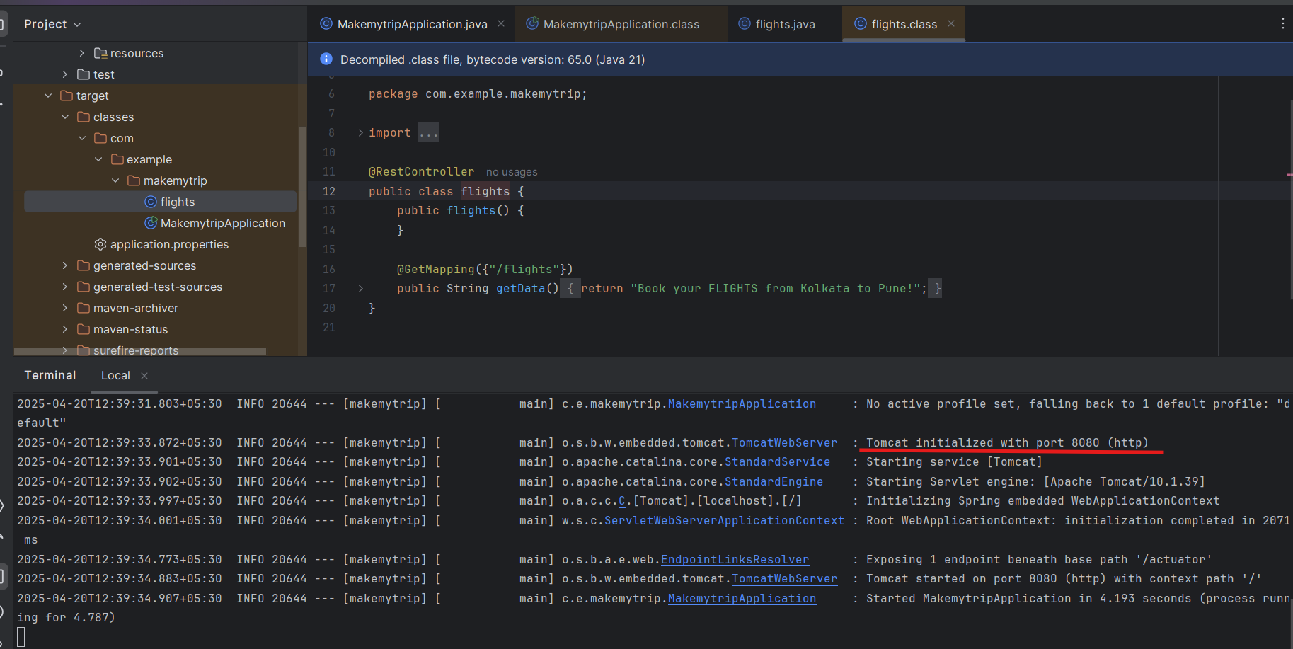

Now run the flights microservice on localhost

<http://localhost:8080/flights>

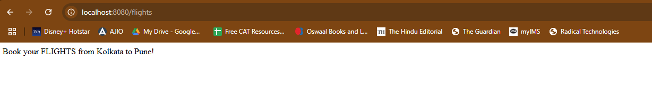

Press control C on terminal and the application will stop. If you check the link again it wont work anymore

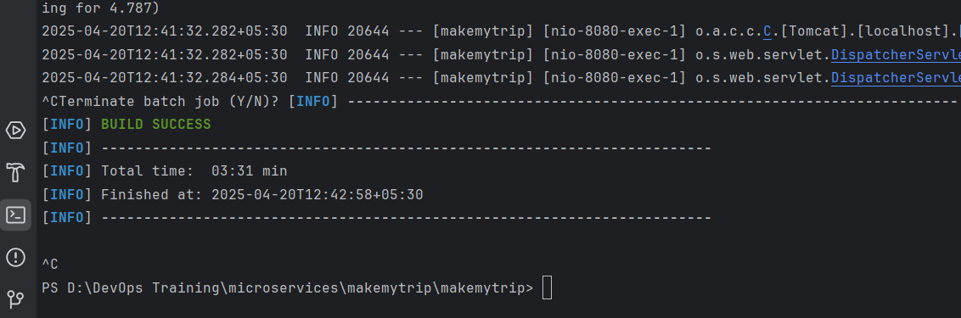

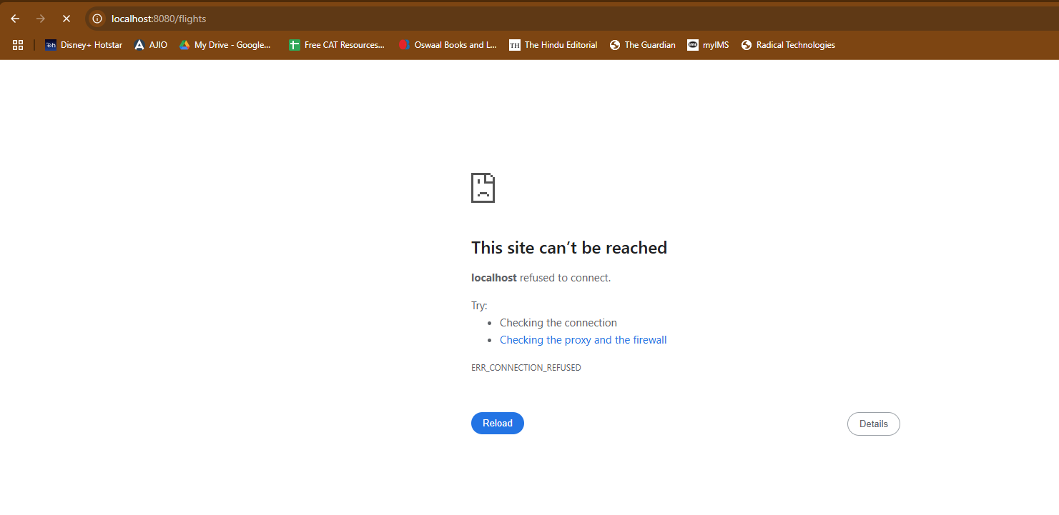

Add new feature now: hotels.java

package com.example.makemytrip;

import org.springframework.web.bind.annotation.GetMapping;

import org.springframework.web.bind.annotation.RestController;

@RestController

public class hotels {

public hotels() {

}

@GetMapping({"/hotels"})

public String getData() {

return "Book your HOTELS for Pune at 50% OFF!";

}

}

Now clean compile and package to make sure the new code is not spoiling the old working code.

> mvn clean compile

> mvn clean package

And then verify both the applications: hotels and flights

> mvn spring-boot:run

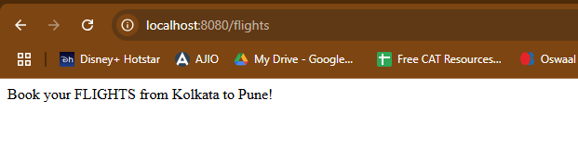

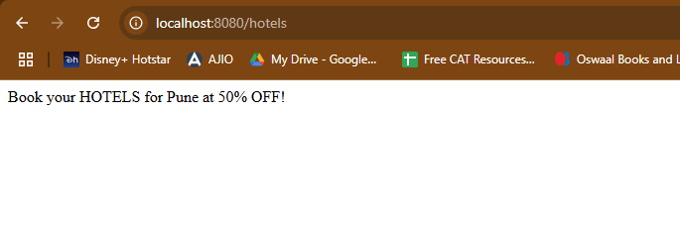

So we can see both features are working on local system.

Once the functionalities are verified and code is working - the code is supposed to be pushed on **github - shared remote code repository**.

Create new repository on Github: makemytrip

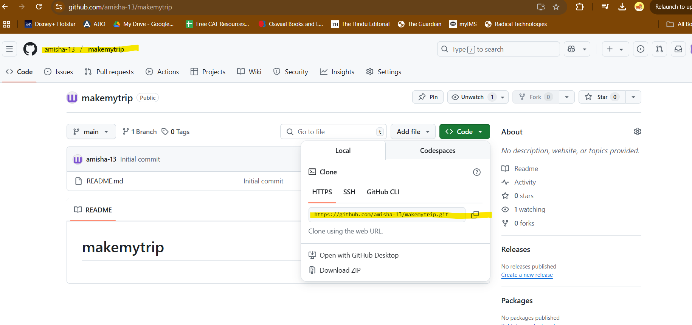

Push the code from local to remote repository

In IntelliJ IDEA enable version control integration:

VCS > Enable version control integration

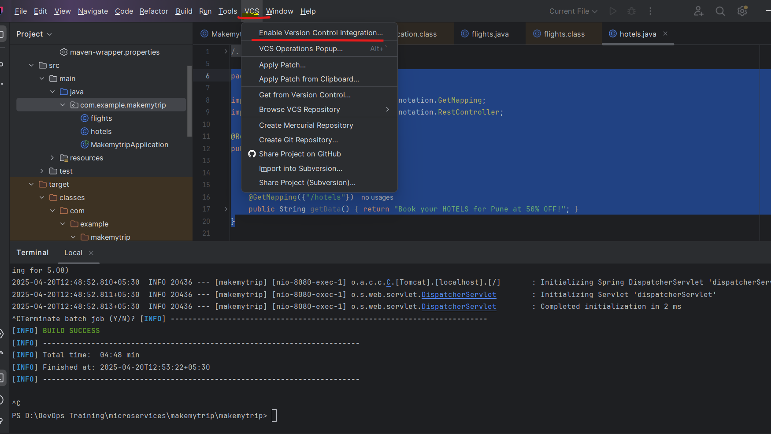

VCS > Manage remote > Enter URL of remote repository just copied

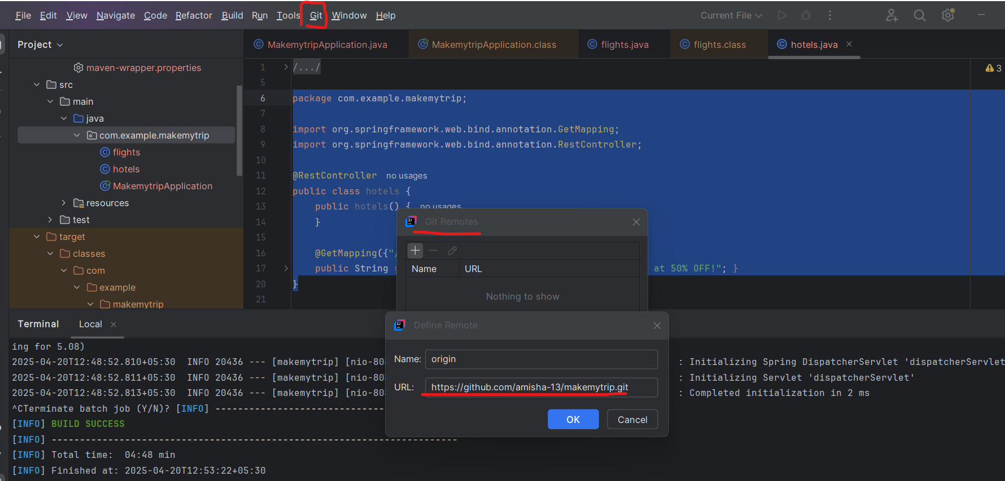

In my case - my default branch name is main and not master

> git pull origin main

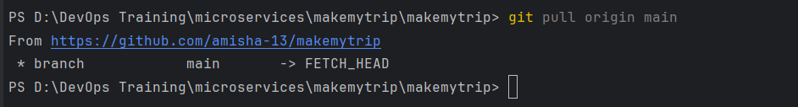

1st time you run this:

git pull

git pull origin master

git add --all

git commit -m "CodeRefactor"

git push origin master -f

2nd and all times

git add --all

git commit -m "message"

git push origin master

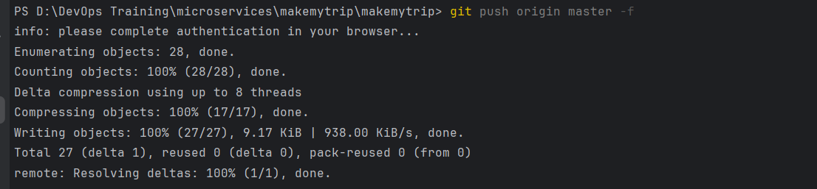

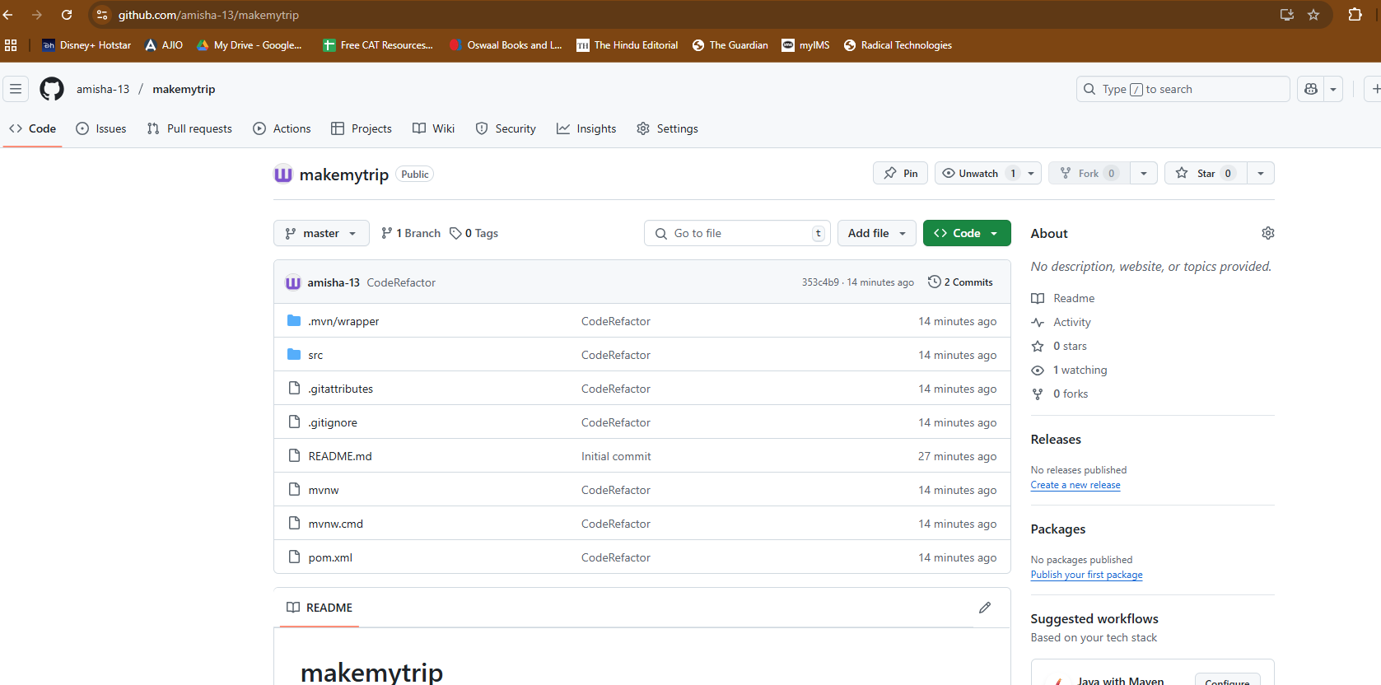

Add new class - bus.java

package com.example.makemytrip;

import org.springframework.web.bind.annotation.GetMapping;

import org.springframework.web.bind.annotation.RestController;

@RestController

public class bus {

@GetMapping("/bus")

public String getData() {return "Book your BUS from Kolkata to Pune at 10% OFF!";}

}

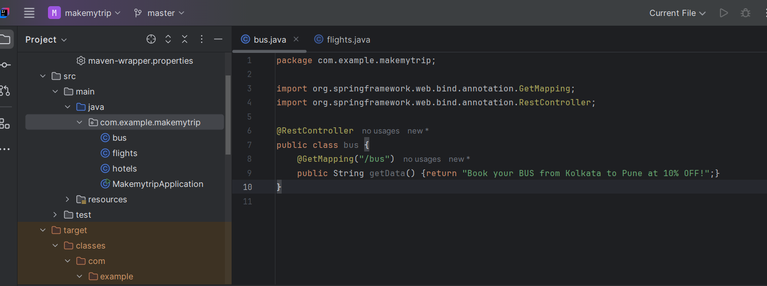

> mvn clean compile

> mvn clean package

> mvn spring-boot:run

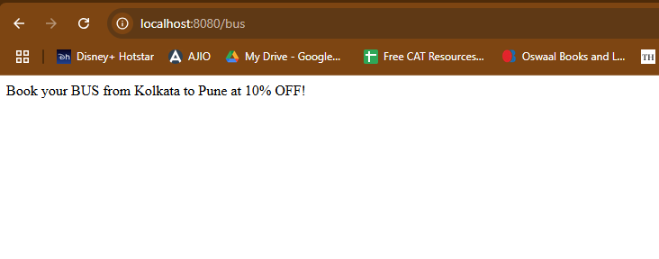

> git add --all

> git commit -m "Adding new java class"

> git push origin master

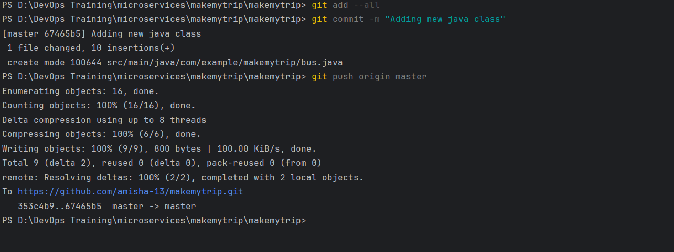

Code is now uploaded

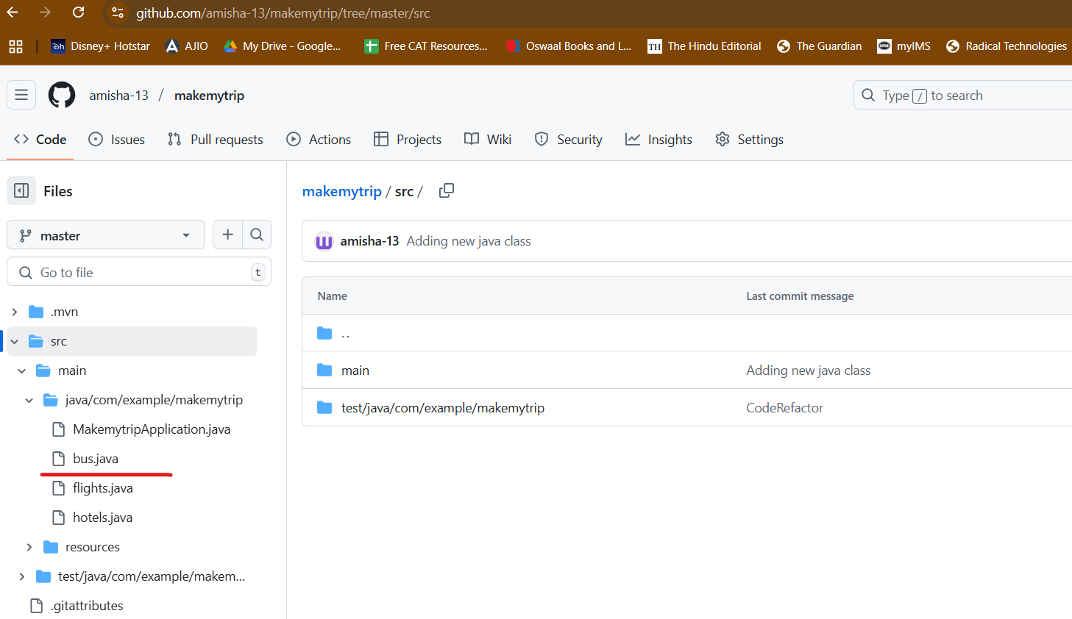

Day 4

Delete repo

Delete makemytrip folder

Perfrom cleanup

Download spring framework

Reopen code in IntellIJ Idea

Create new repo: makemytrip

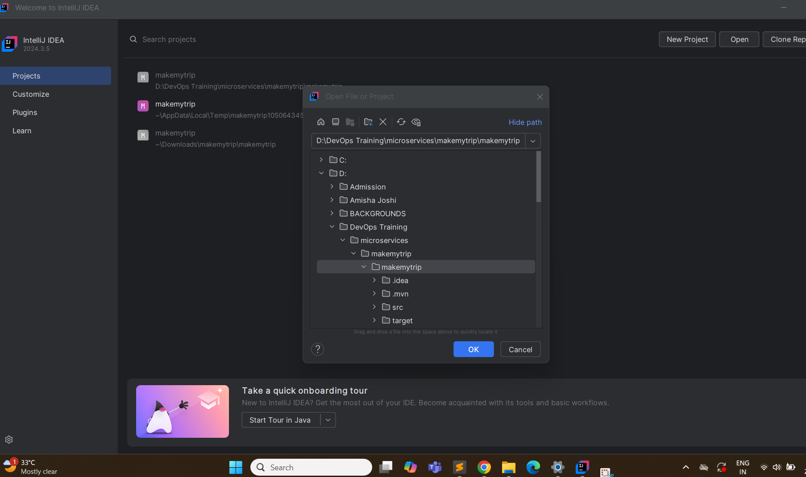

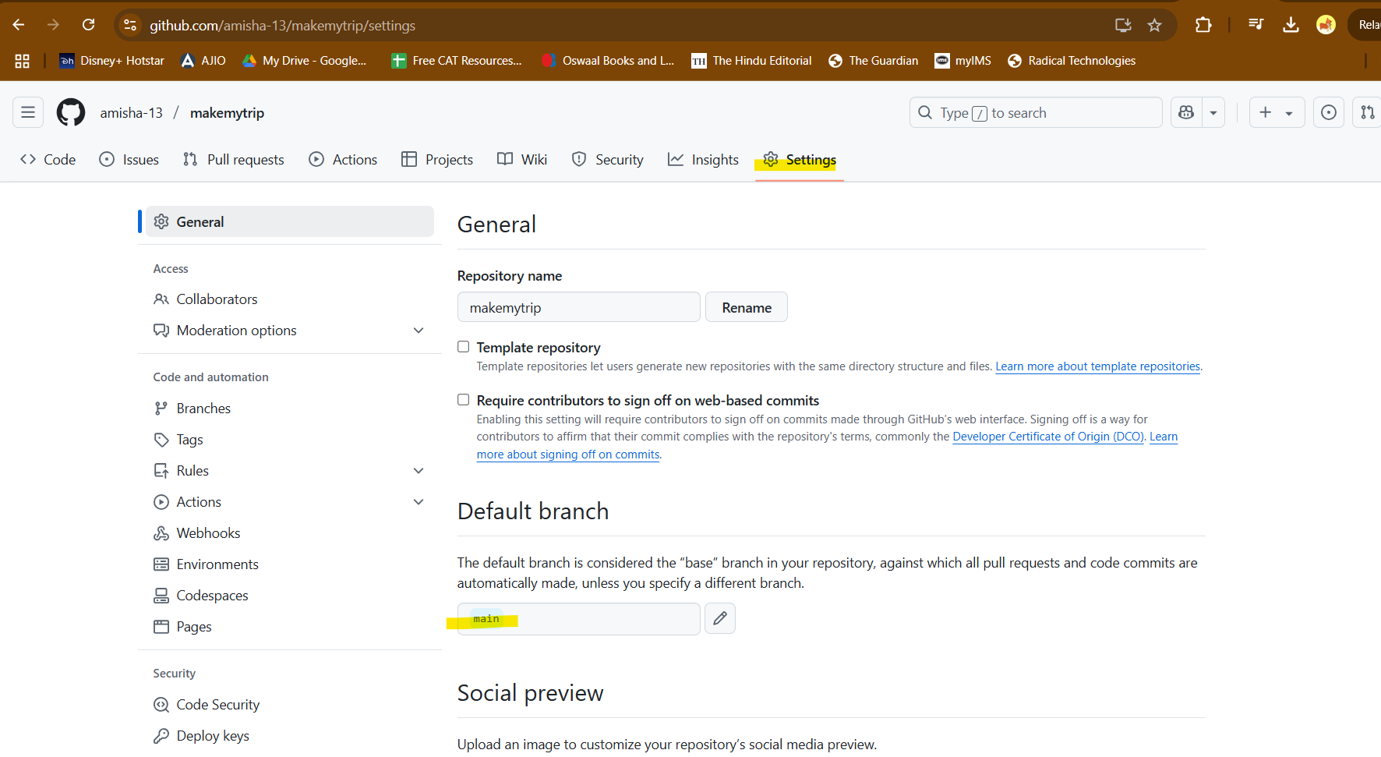

Change branch name to master

Enable Version COntrol on IntelliJ

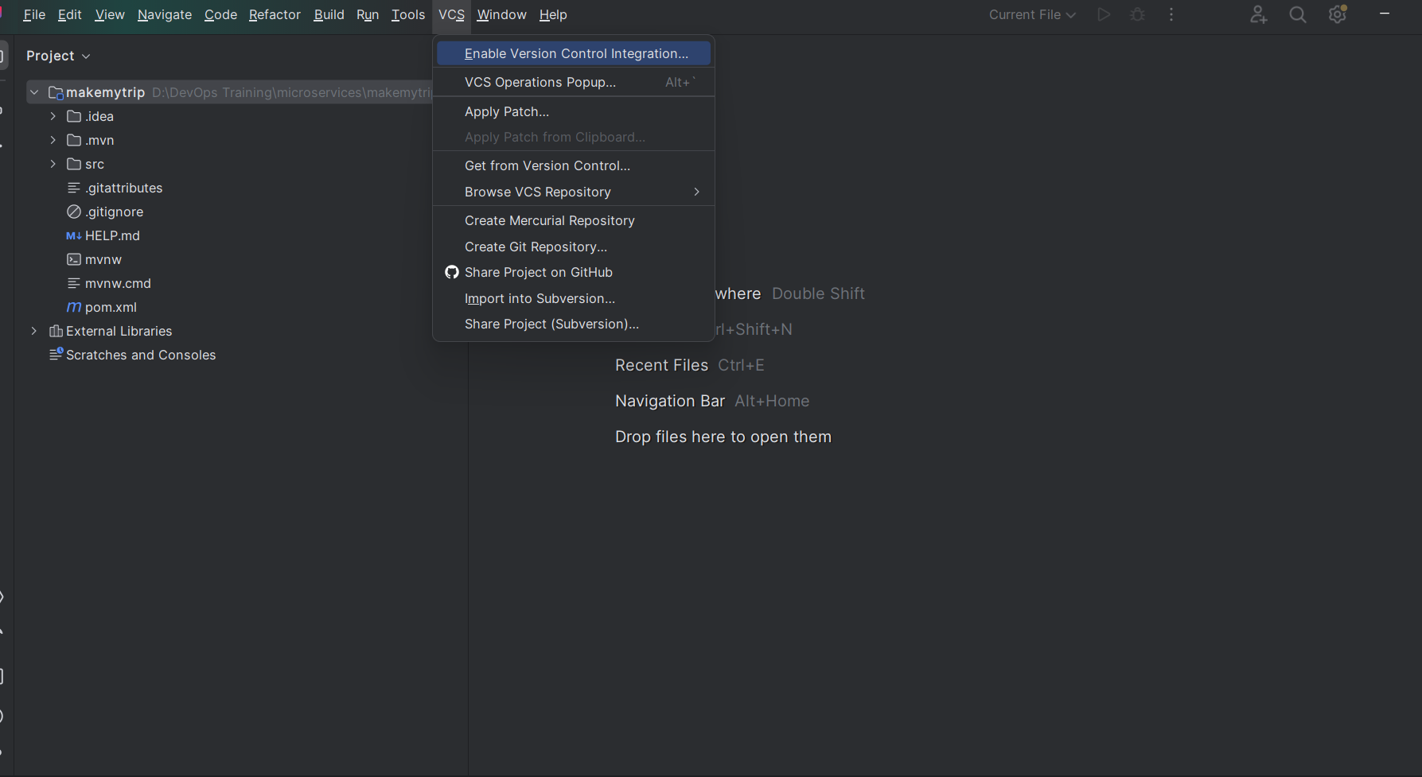

Select Git as the tool

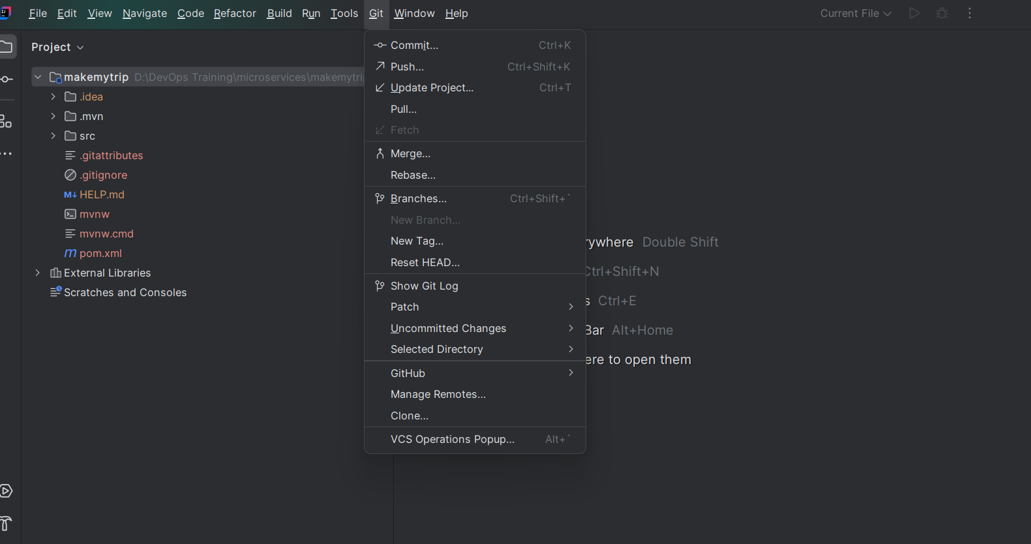

Now add remote repo: VCS> Manage Remote: add your git URL

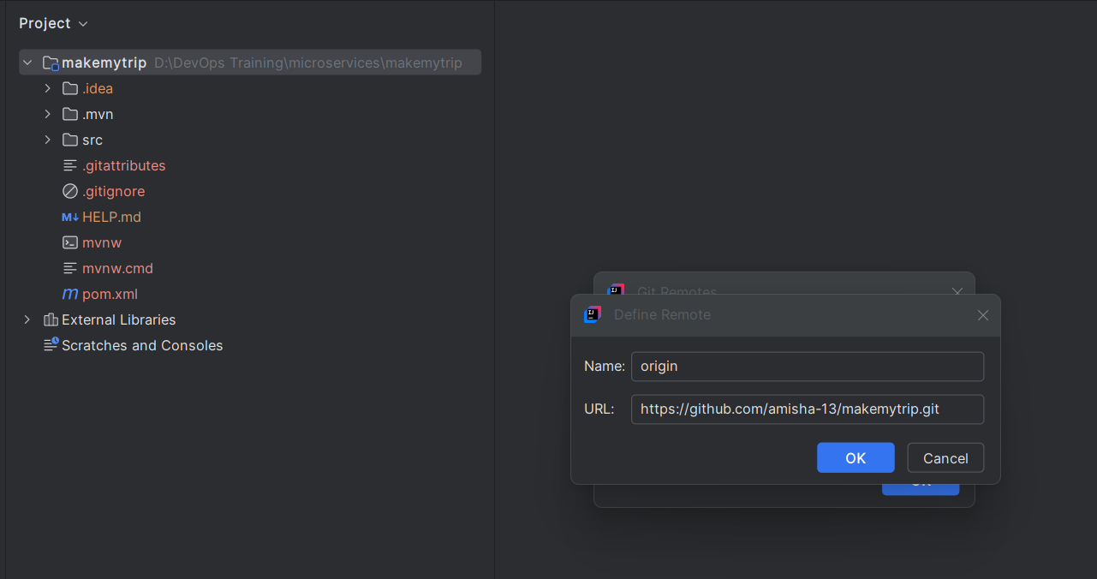

First time run:

> git pull origin master

> git add --all

> git commit -m "CodeRefactor"

> git push origin master -f

Created flights.java

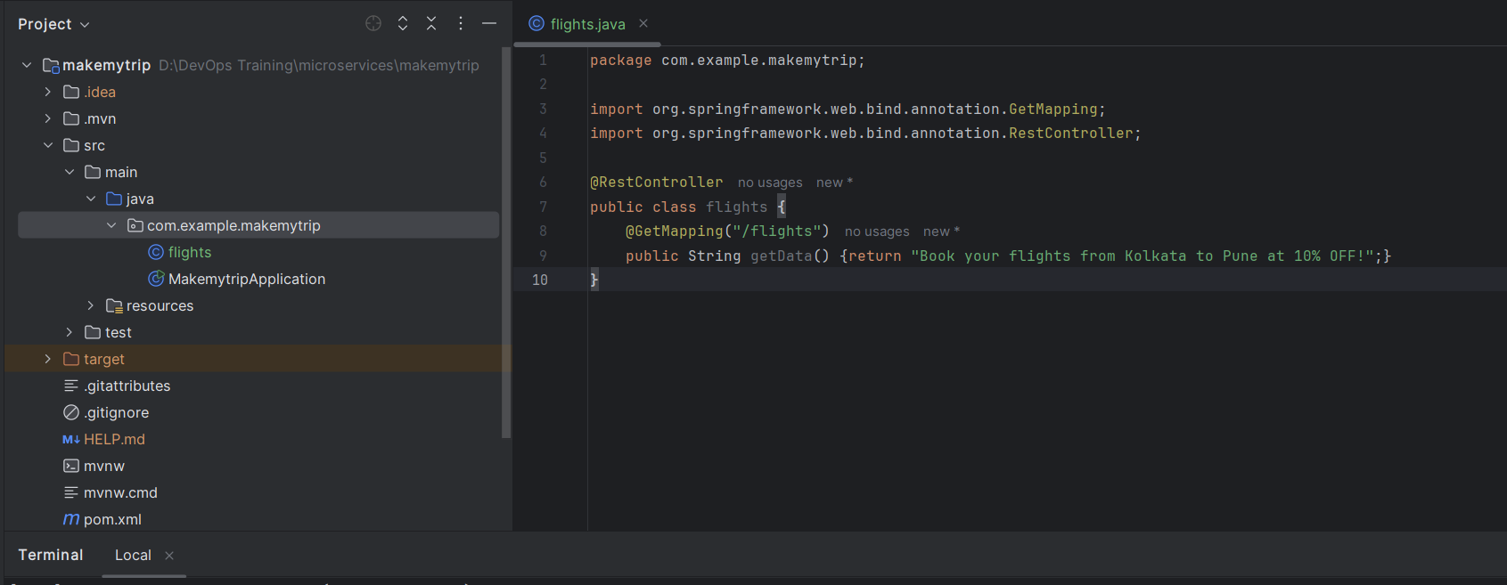

> mvn clean compile

> mvn clean package – jar file created

To create .war packaging - add this in pom.xml

<packaging>war</packaging>

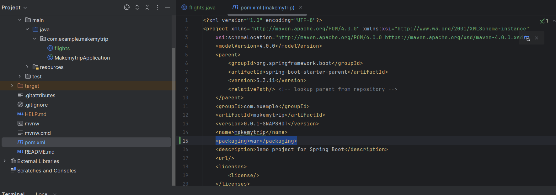

Now > mvn clean package

Created war file

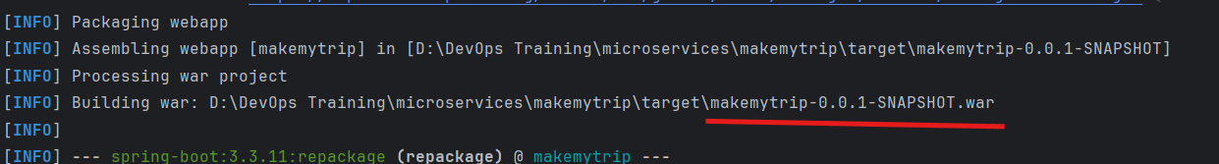

This is not added in remote repo:

> git diff

Tells the changes

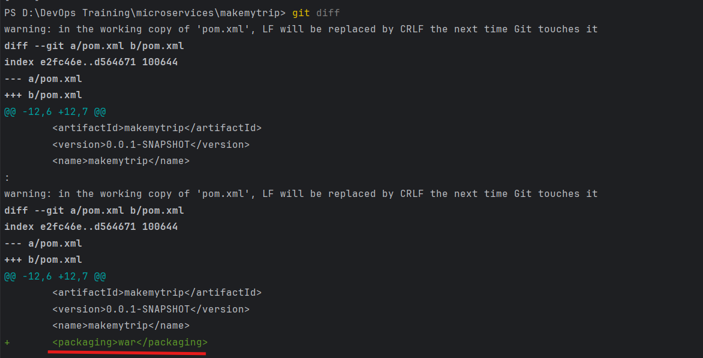

> git add --all

> git commit -m "Change in pom.xml"

> git push origin master — Move from local to remote

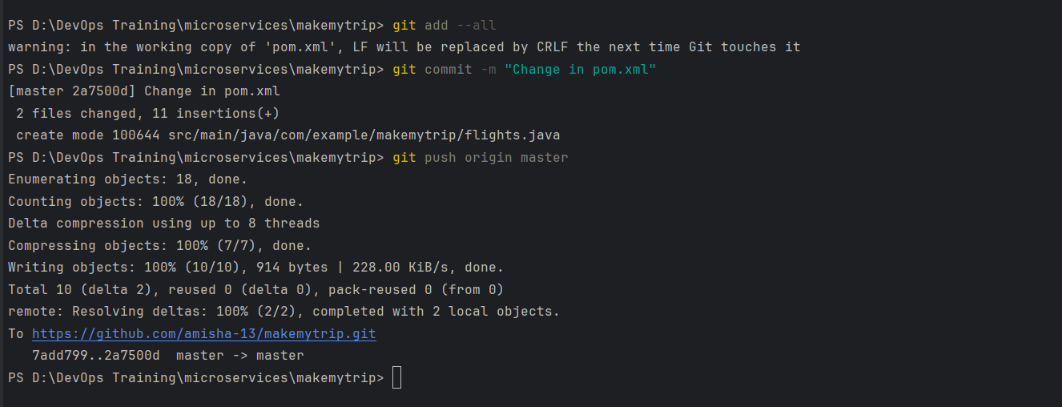

This is reflected in remote repo as well

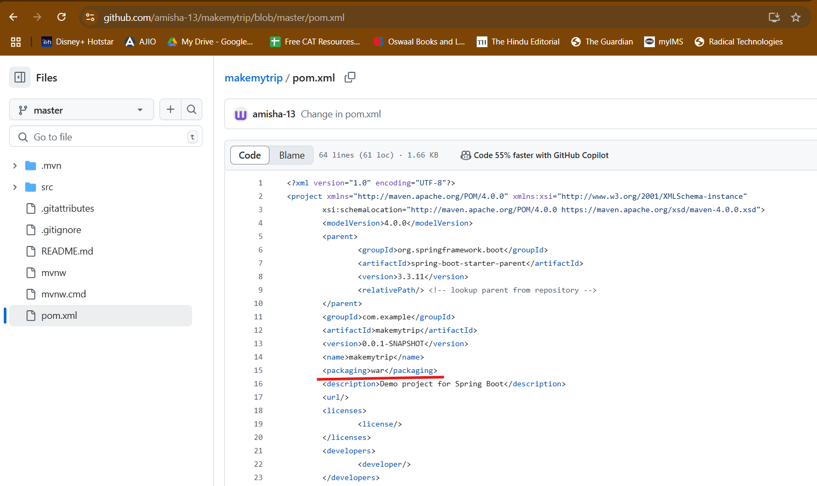

Create brand prod from master, preprod from prod and dev from preprod

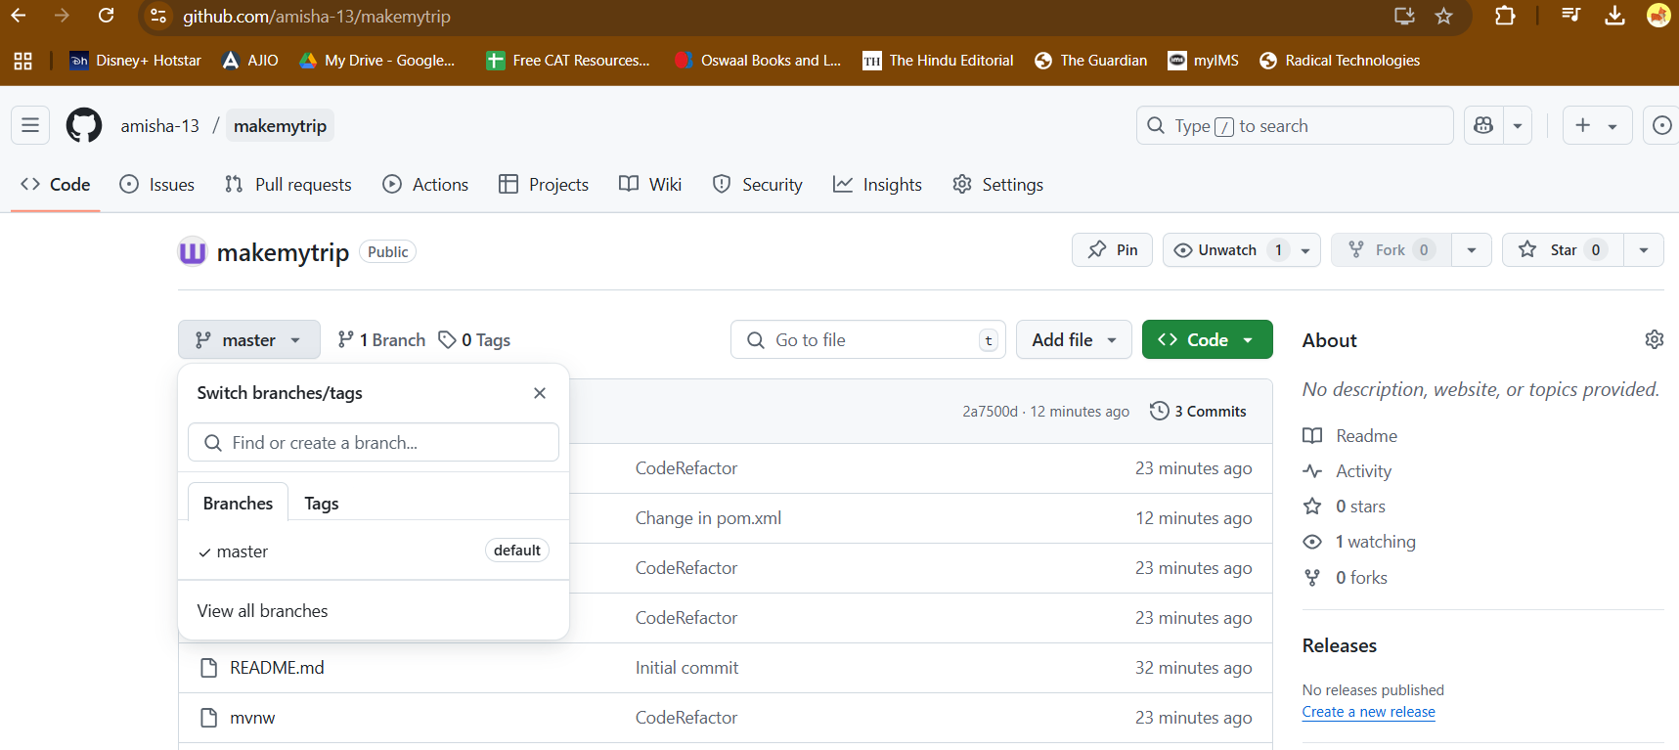

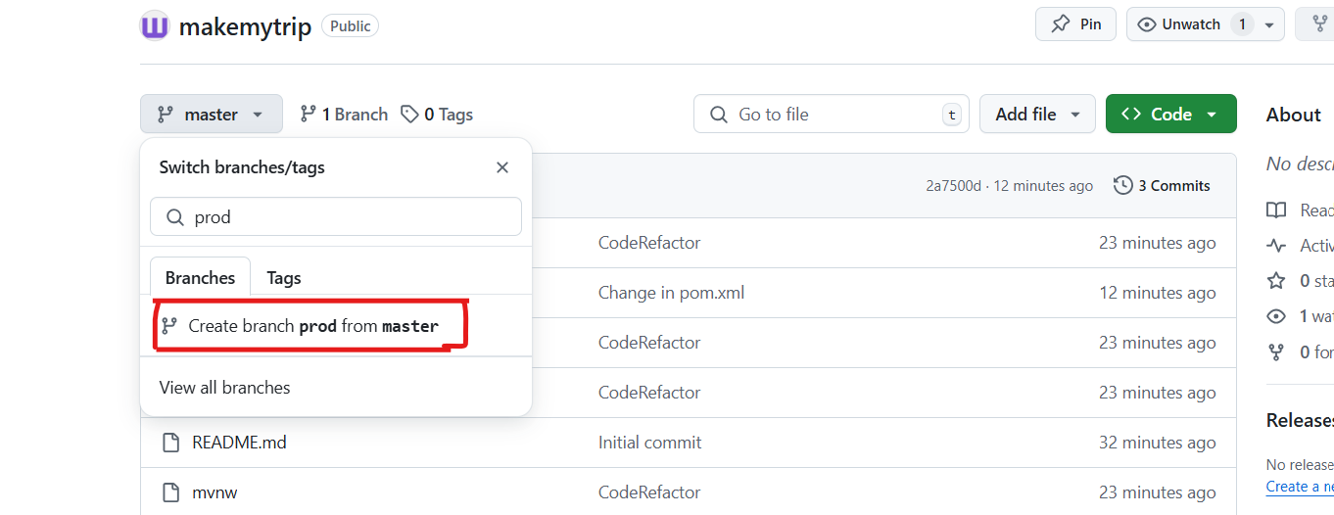

CHeck which branches you have

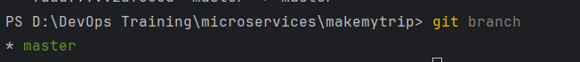

Dev is the lowest branch and We dont have dev branch in local

So:

Git fetch origin dev – get from remote to local

Git checkout dev – switch the dev branch

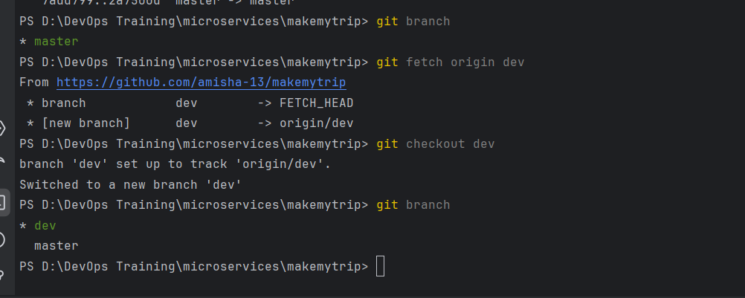

Make new java class : flights.java

Make some changes in pom.xml

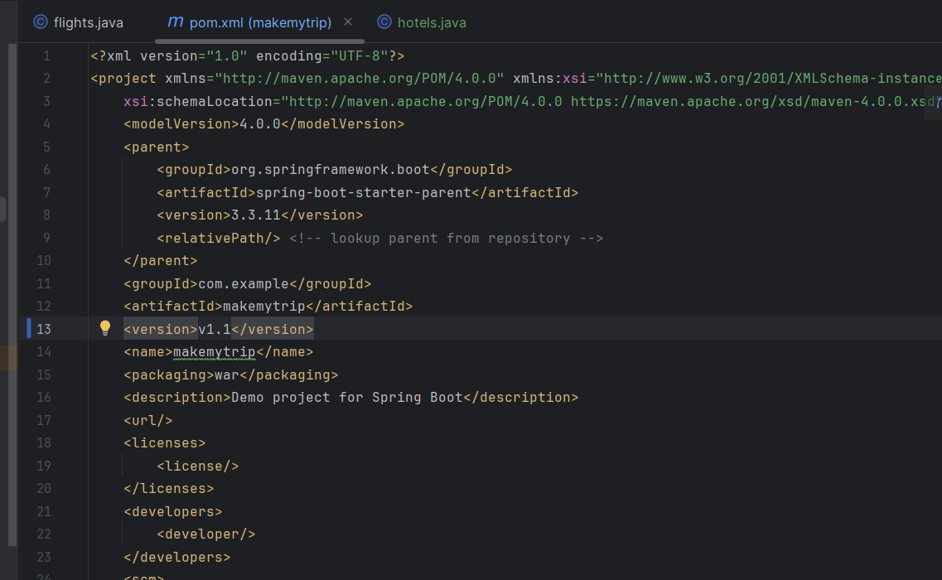

Git status – will tell changes modified in working directory

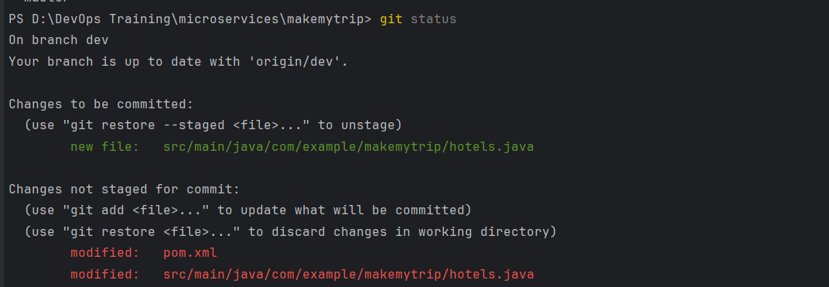

Now since i added new java file, package it

> mvn clean package (Runs compile also by default)

> git add --all

> git commit -m "New java class"

As a dev, I cannot push code in any other branch but dev

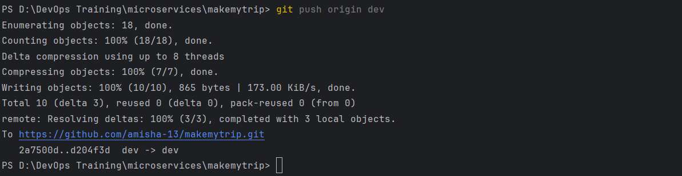

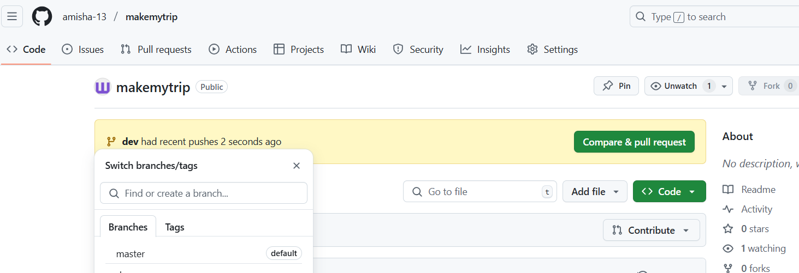

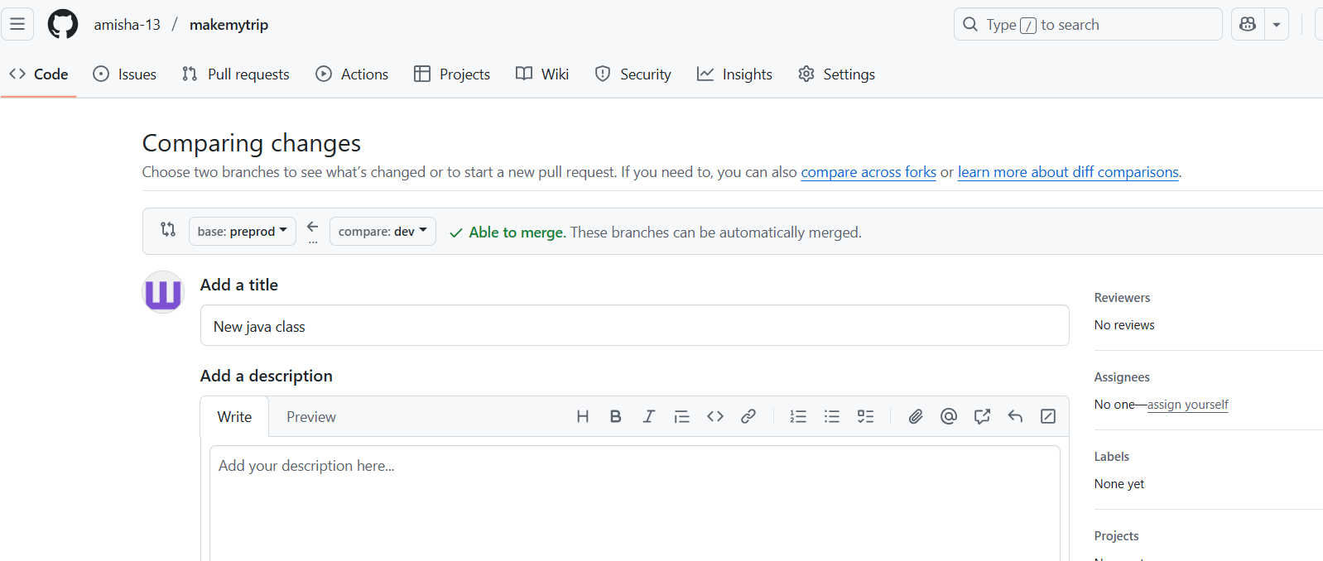

Dev changes will be merged into preprod only

And Preprod in prod

Prod need not be merged with master

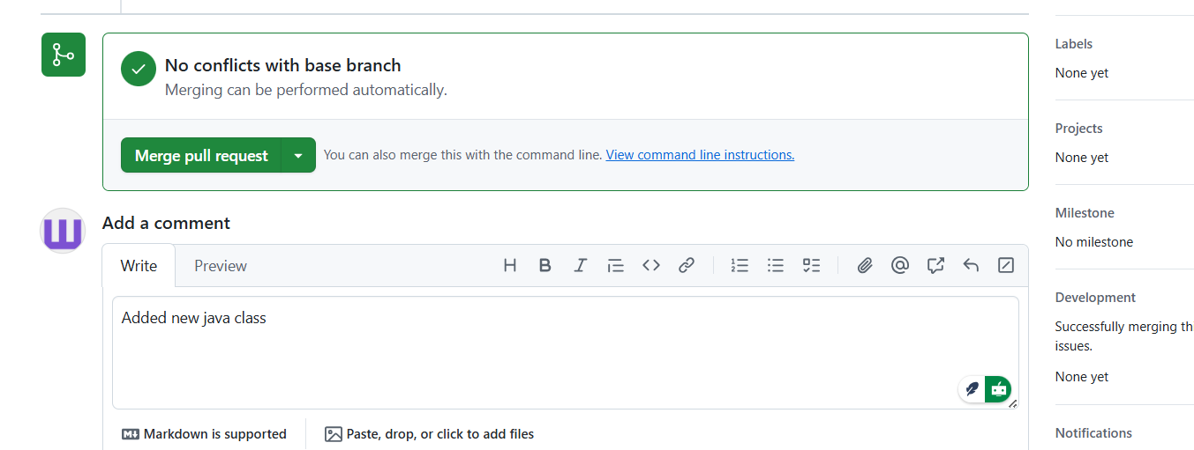

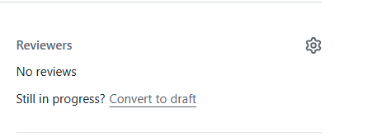

Add in reviewers, but you cannot approve it yourself

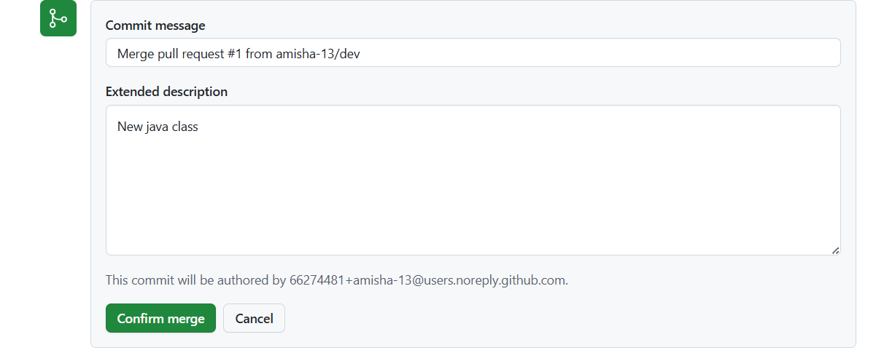

Confirm merge

Now push preprod changes to prod

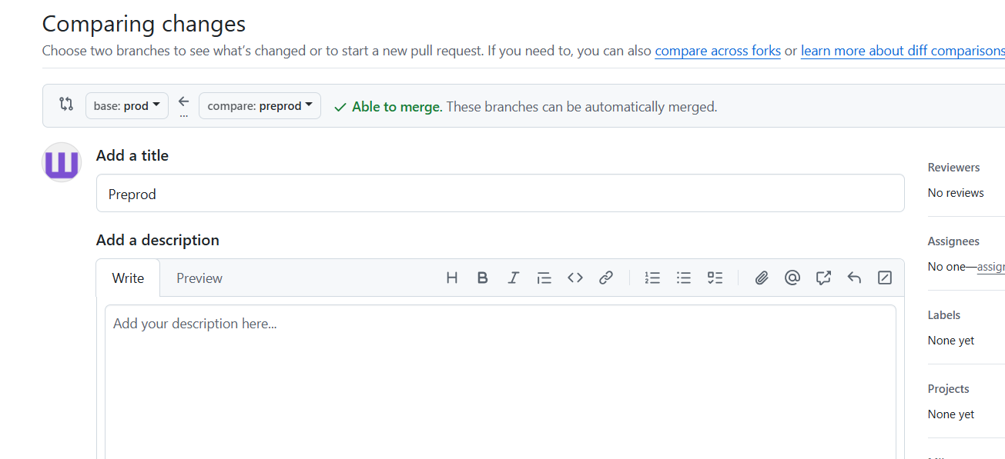

Because code is now deployed in prod already so no need to add it into master

> git pull origin dev – Dev branch files of remoted will be synced with local repository

> git checkout -b feature/holidays – new new branch from dev in local

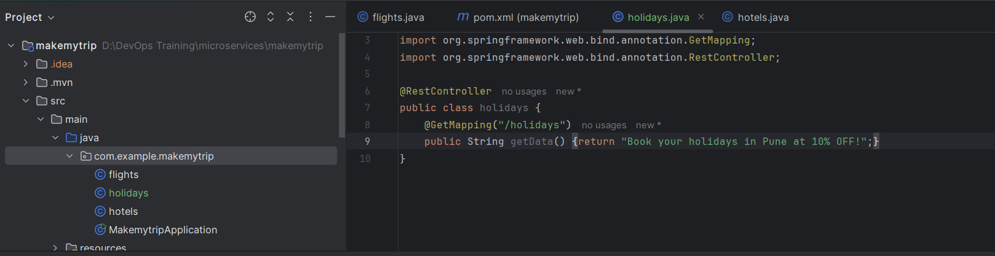

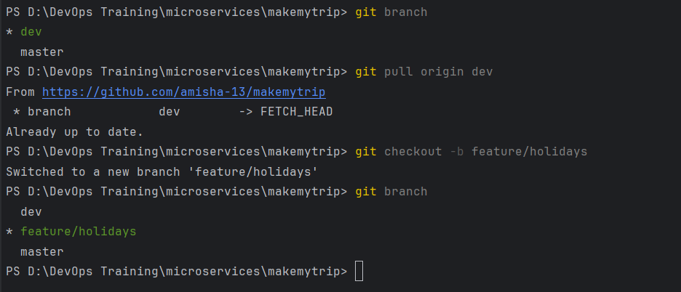

Make a new java class file: holidays.java

Run

>git status – to see the differences

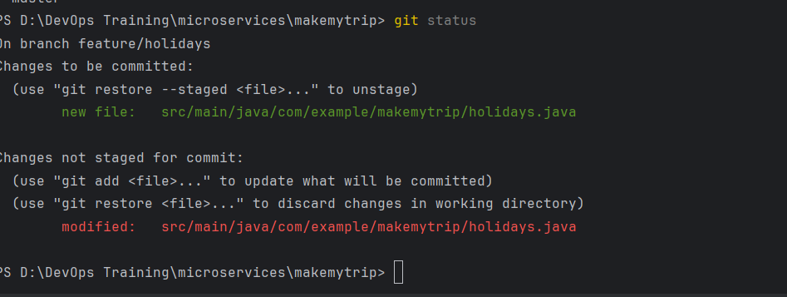

> mvn clean package

> git branch – make sure it is feature branch

> git add --all

> git commit -m "Adding new java class"

> git push origin feature/holidays

Now pushed into feature/holidays (local branch)

We can see new branch coming up in remote

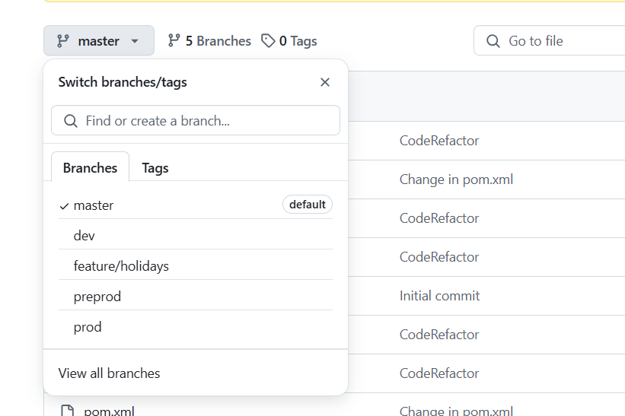

Push changes to dev

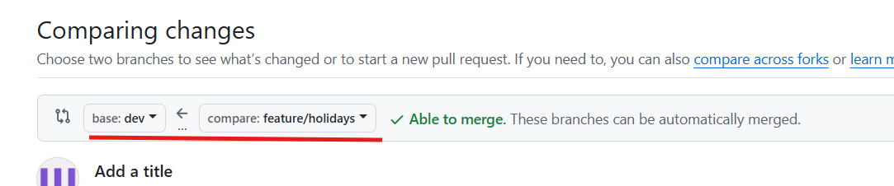

After merge, feature branch can be successfully deleted if you want

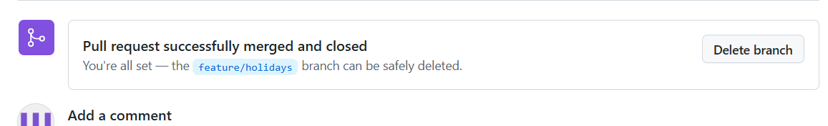

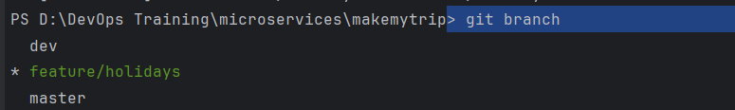

Pull dev from origin and Switch to dev

> git pull origin dev

> git checkout dev

This shows my dev branch is behind the remote

SO remote is UPSTREAM

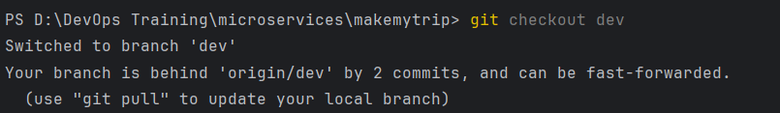

To bring in sync, pull the changes:

> git pull origin dev

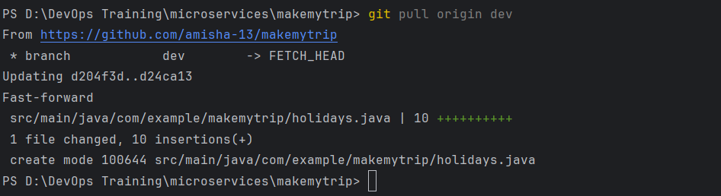

Now it is up to date with remote

Day 5: 27th April 2025

Made changes in pom.xml remote repo

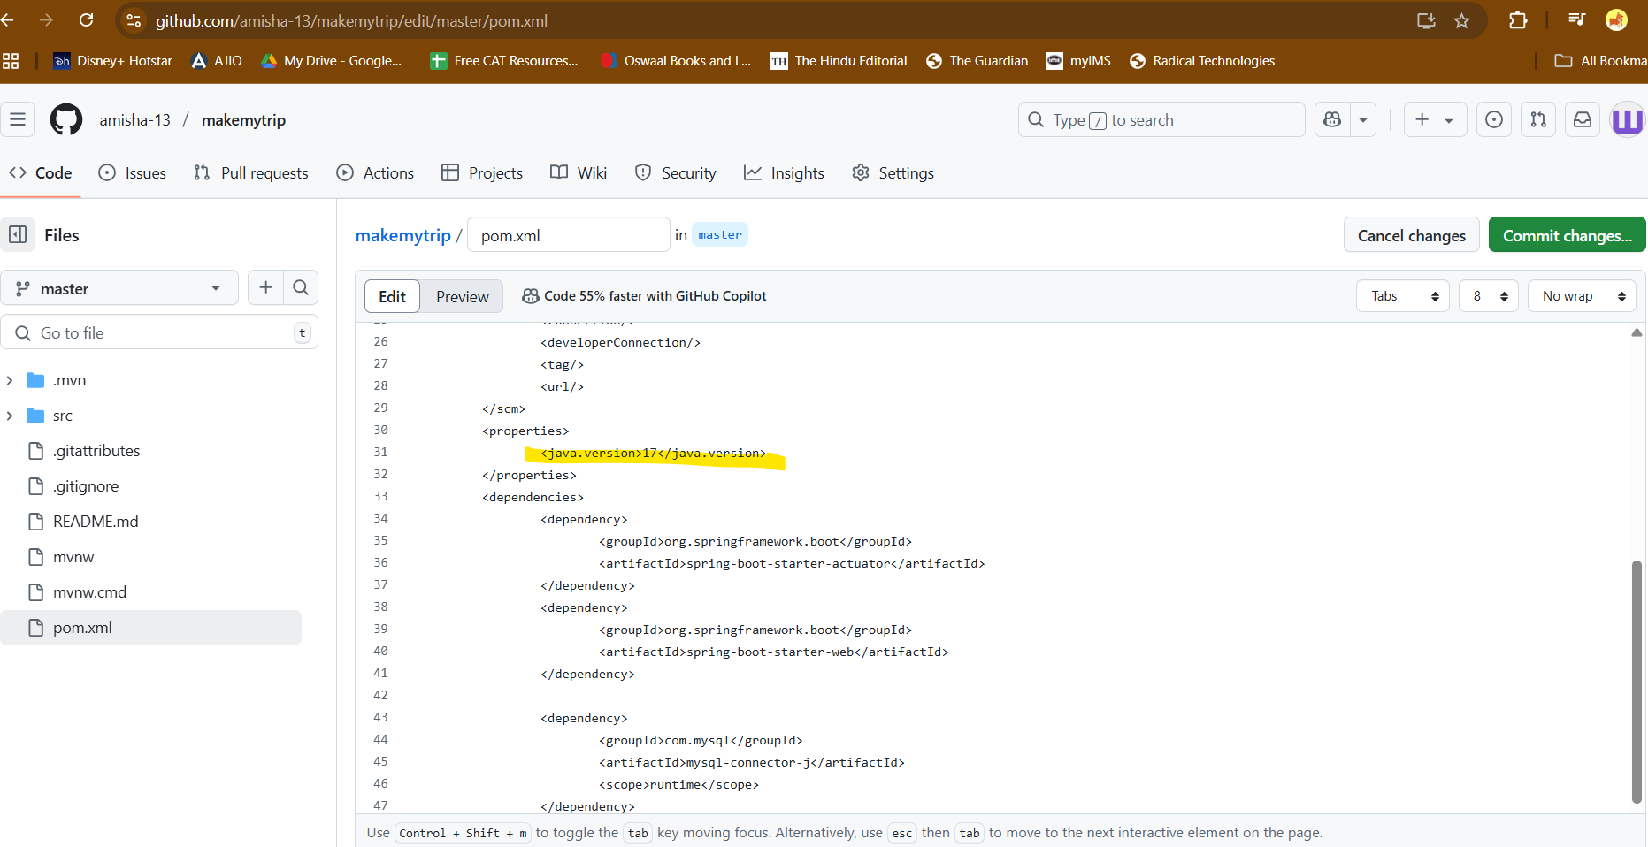

Made changes somewhere in local file as well

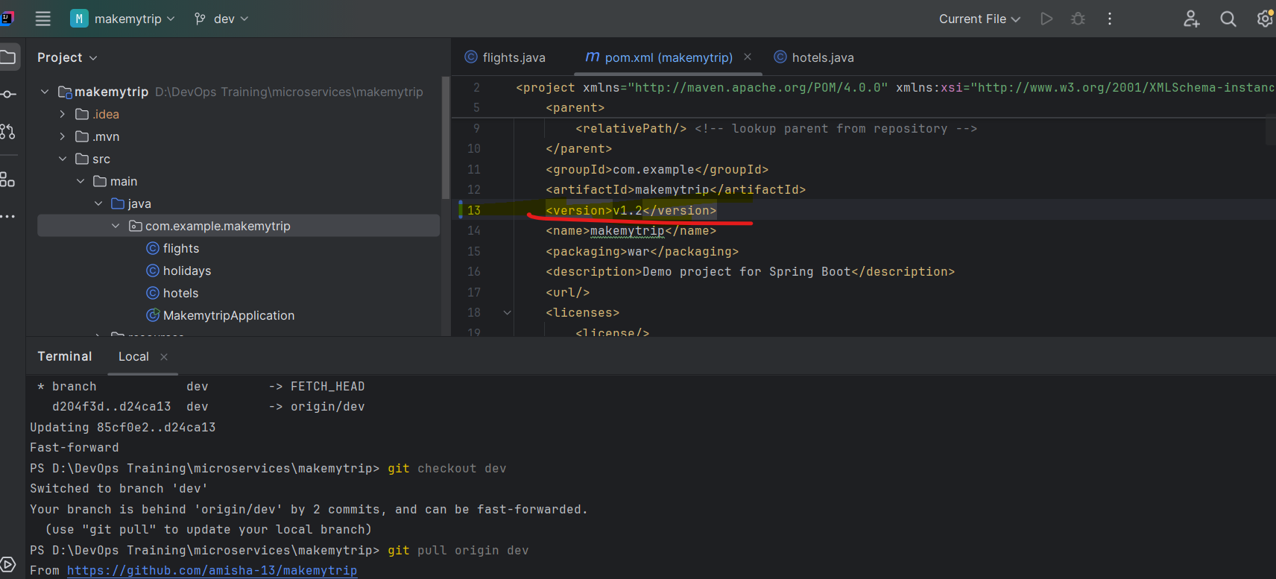

Now when we pull the changes in local from remote using git pull

Make any changes in pom.xml file

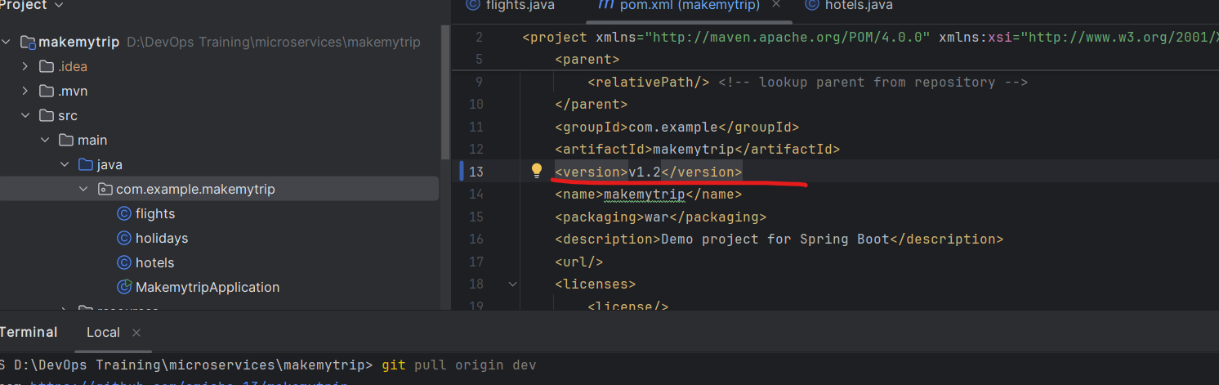

Git diff will show the difference - change within the file

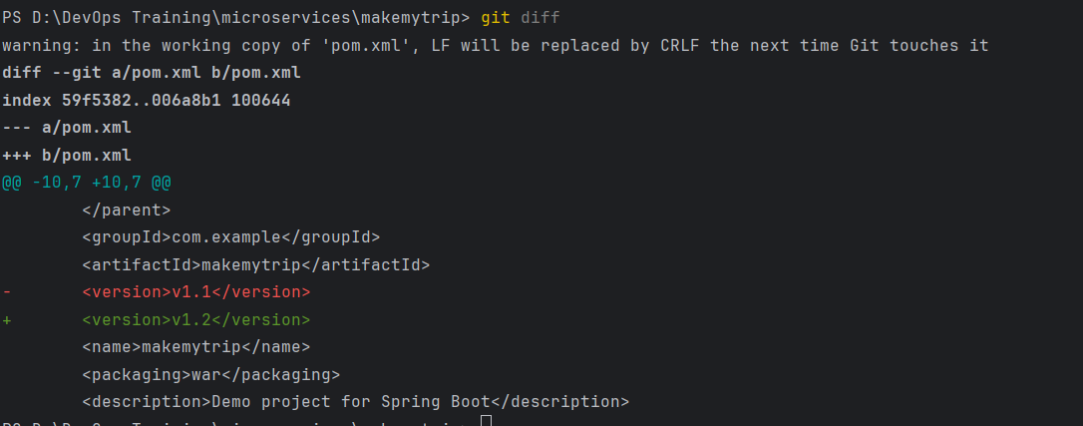

Git status will show the name of the file modified

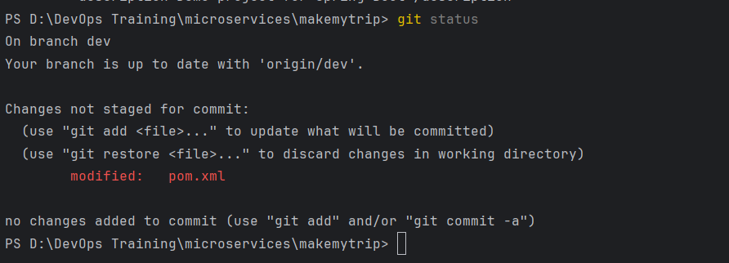

In remote DEV branch, make some changes in pom.xml file

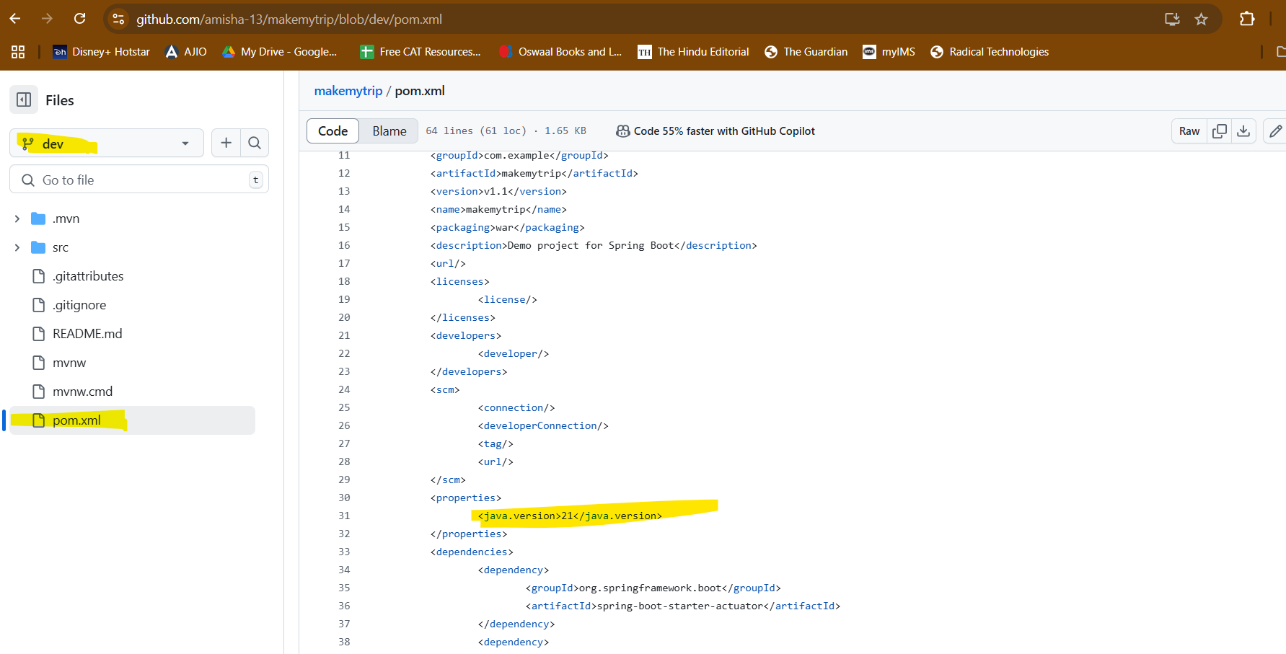

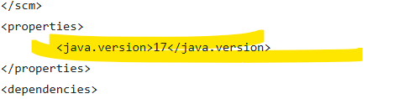

Commit changes in github

Now in local:

Check the branch you are on and make sure it is dev

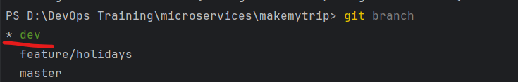

Now sync the changes using git pull

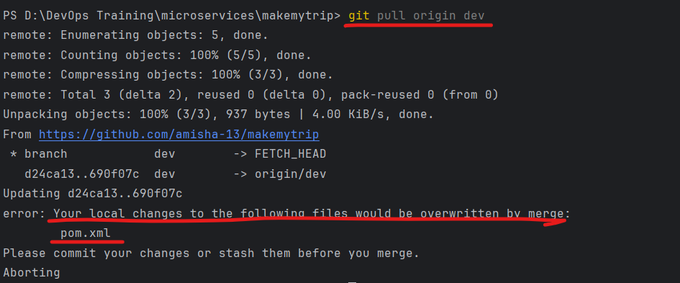

This is showing error because we made changes in both places (local and remote)

So roll back the changes in local and pull the changes

Roll back changes in local using - git stash (undo changes in local repo)



Now you can pull the changes:

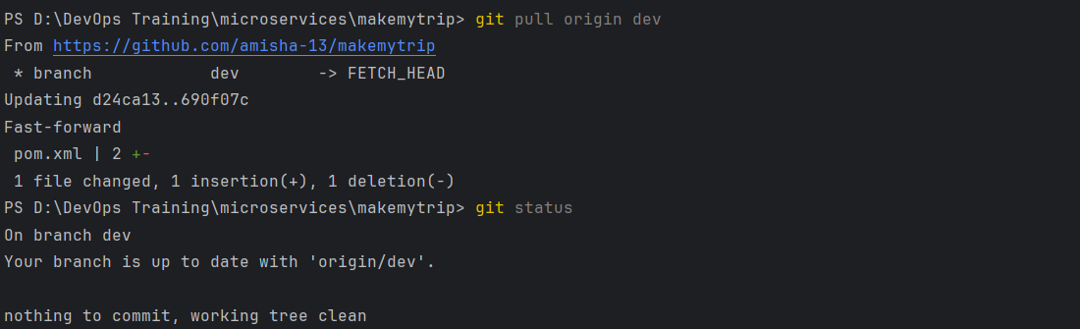

Make changes in a file

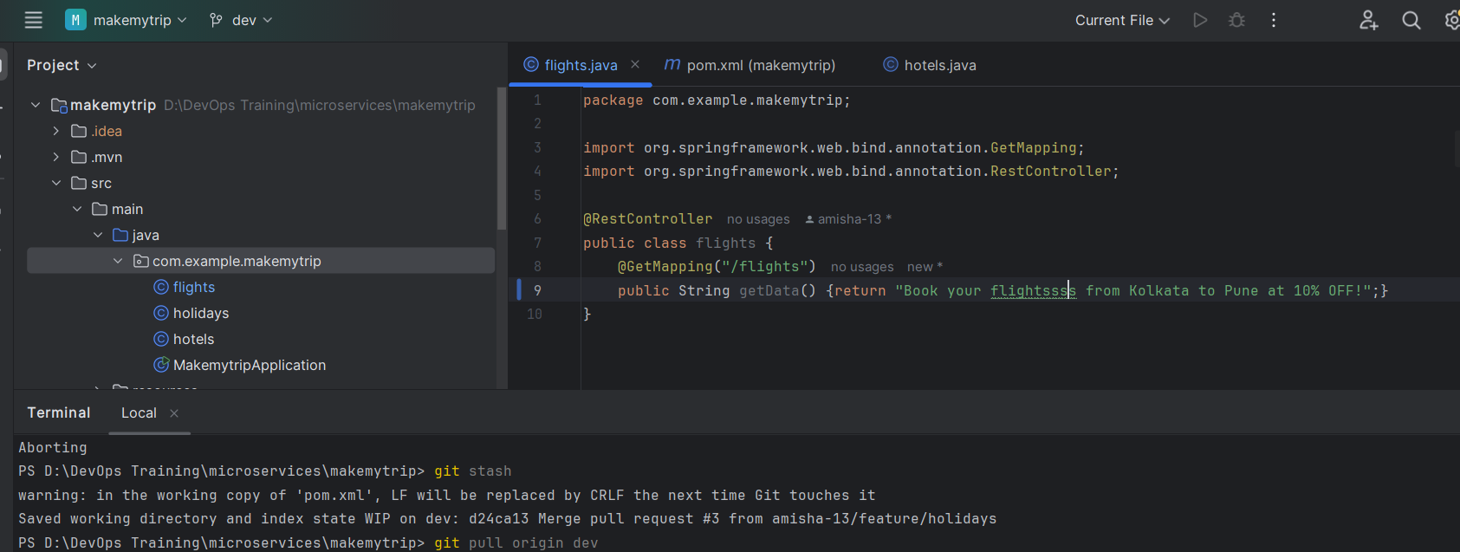

Git status

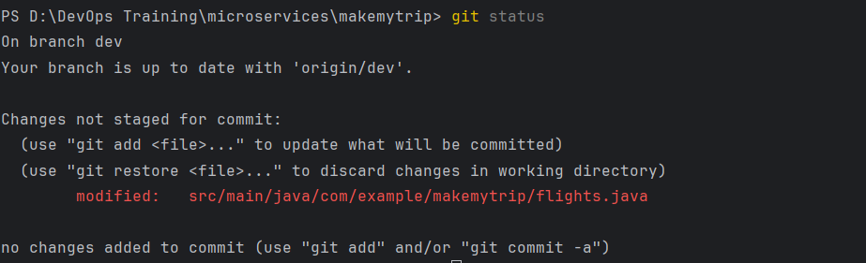

Shows modified changes in red

Git add will add it to staging area and red will look in green

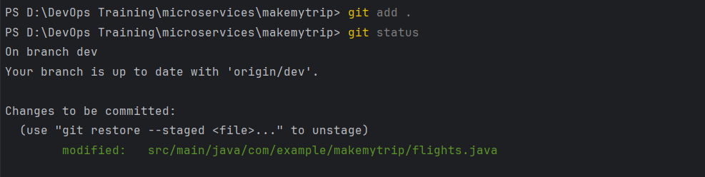

Now use git stash and it will still undo the changes

Meaning - changes can be stashed even from staging area



Git clone:

Git clone <https://github.com/amisha-13/makemytrip.git>

Once local branches are merged, they can be deleted.

To delete local branches - use - git branch -D <branch name>

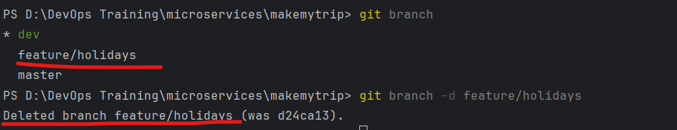

You cannot delete a branch you are ON



Branch protection rules

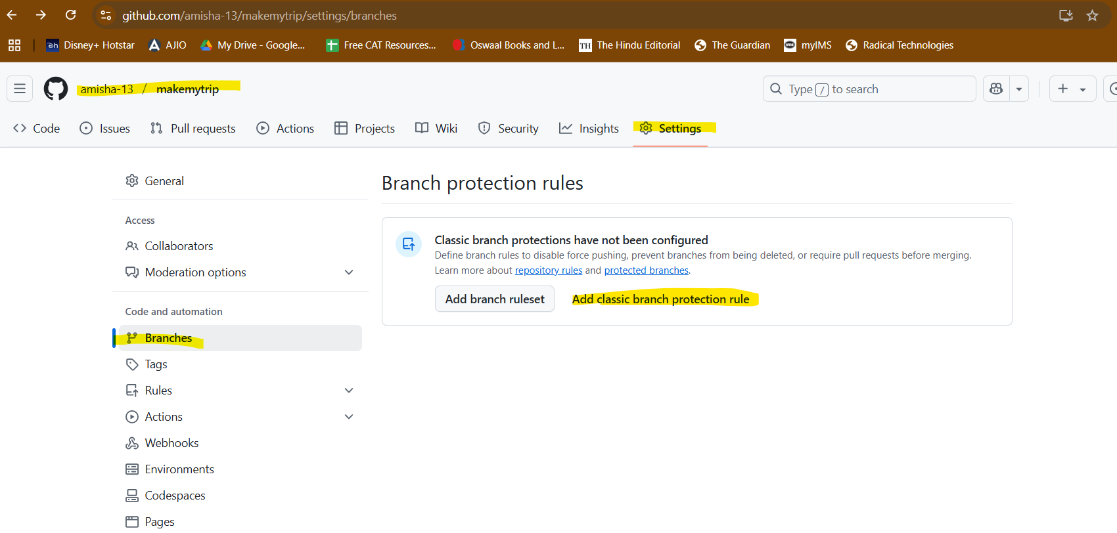

Require pull request

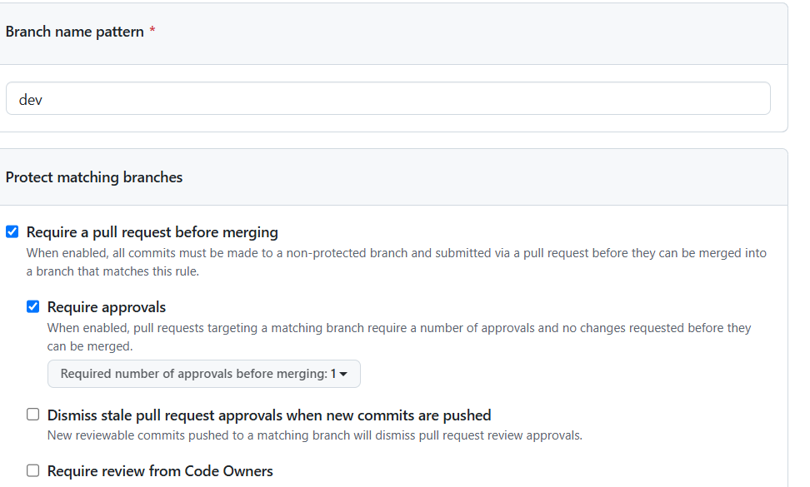

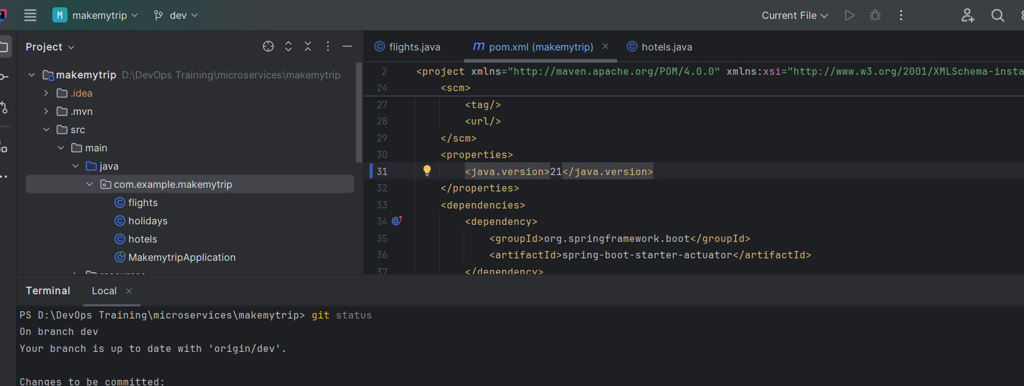

Make changes and try pushing it now - it will not allow you

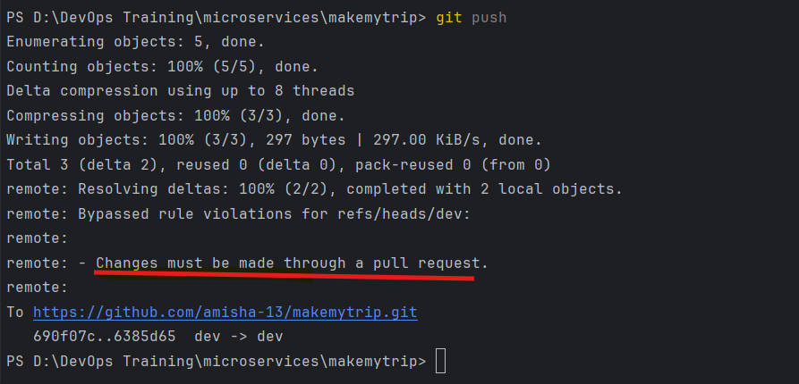

Require approvals from CODEOWNERS

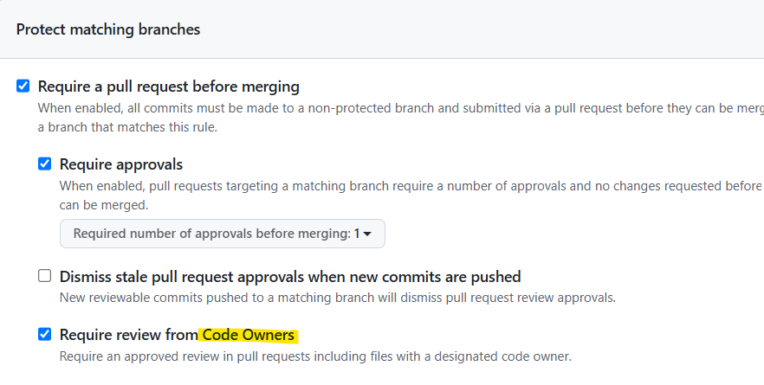

Create CODEOWNERS file and add names of code owners to approve

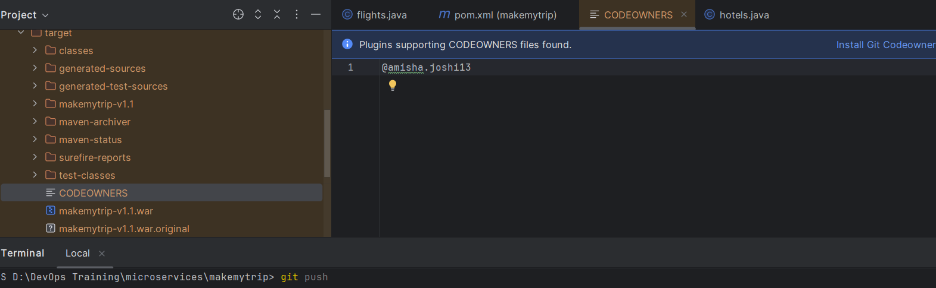

Merge Conflicts:

As Dev A

Right now everything is clean

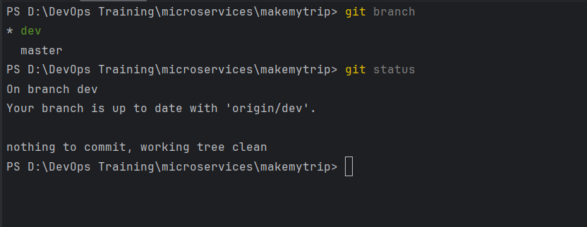

Added new file in dev branch

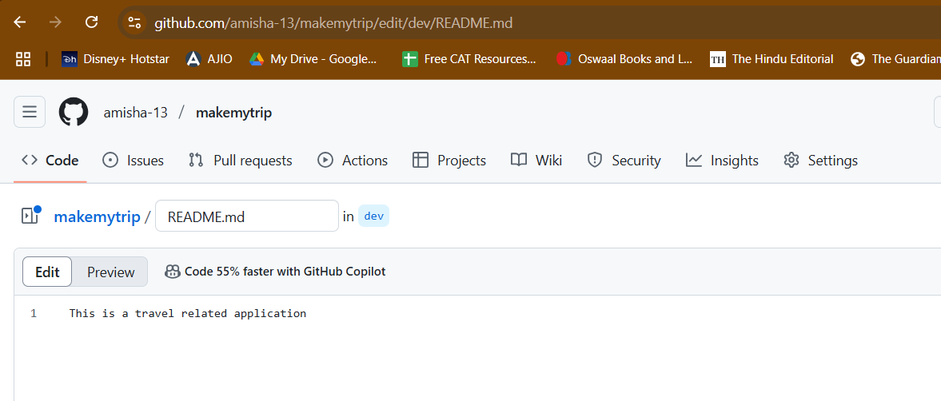

But we dont have this file in local as dev B

Dev B added new file: CODEOWNERS

Made modification in codeowners file

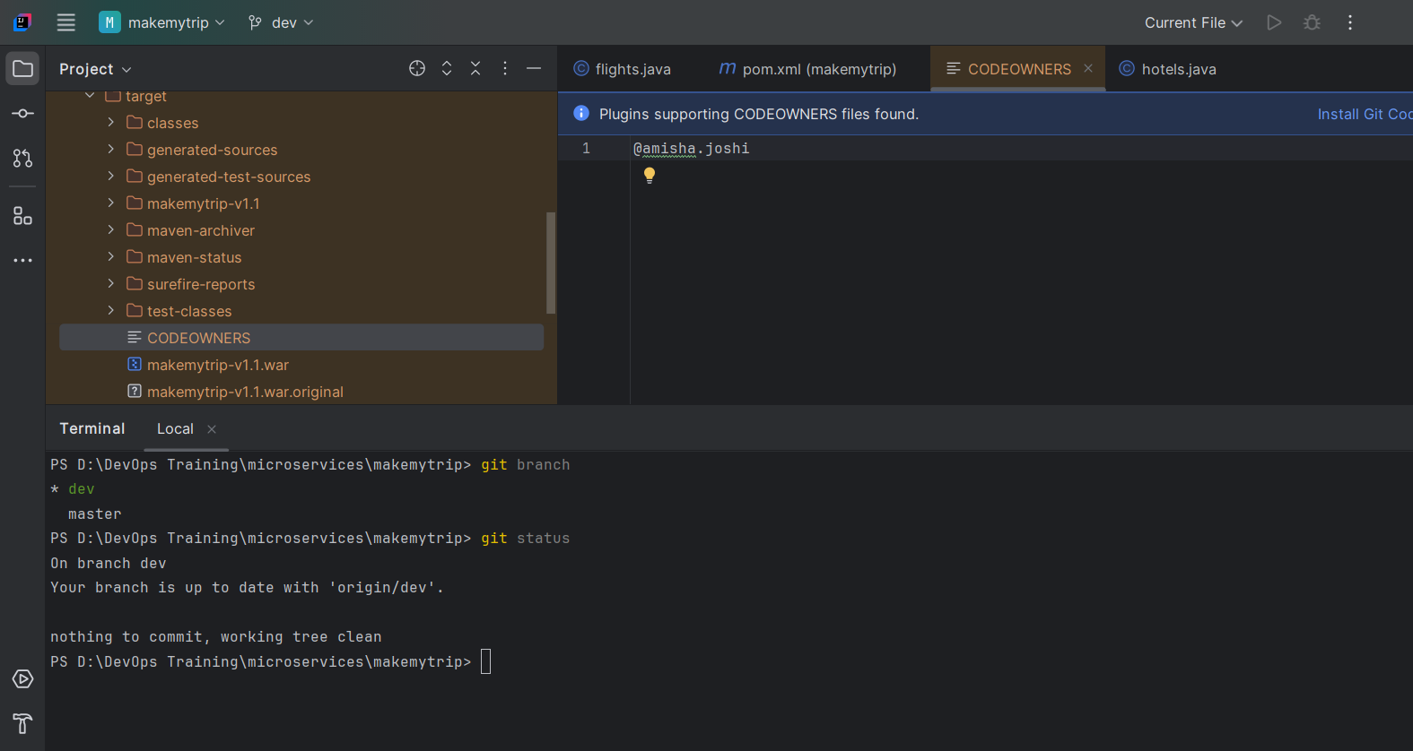

Now DEV B:

Git push will give error: remote repo has work which you dont have in local

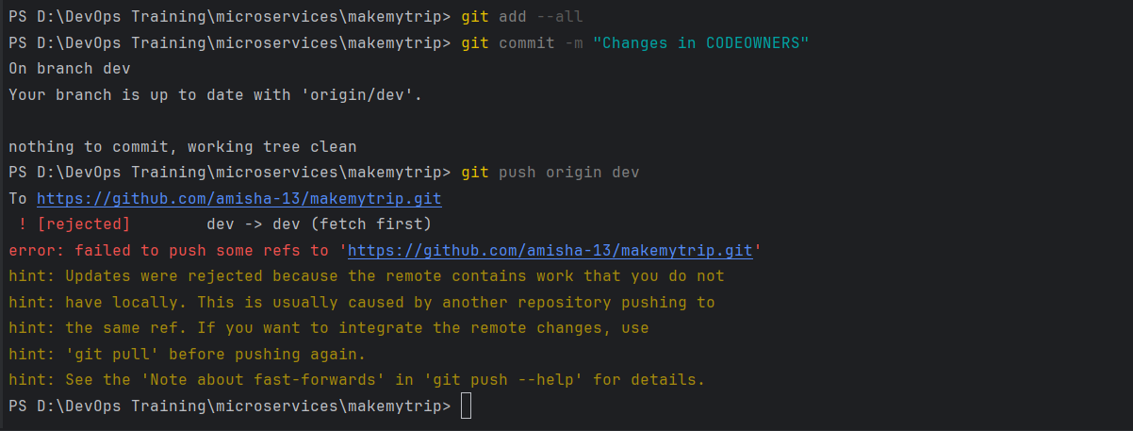

This is called merge conflict

So to resolve:

Git pull origin dev – will pull the changes from remote to local

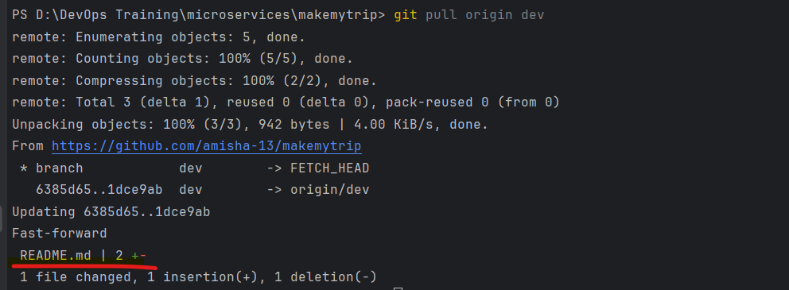

This pull the changes

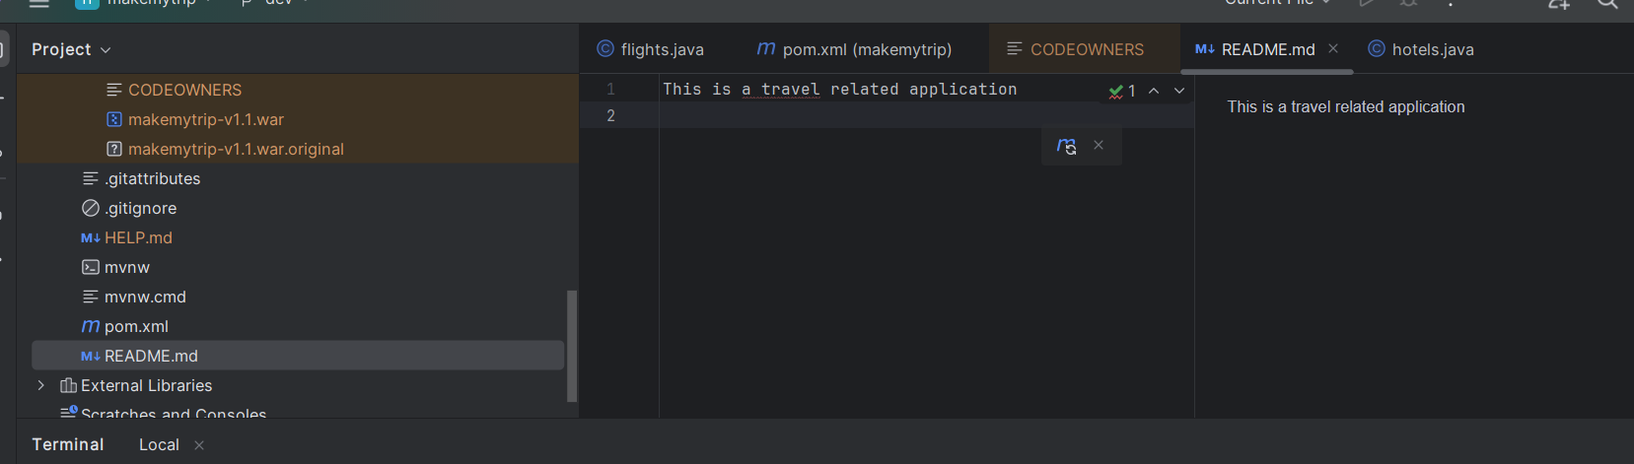

Now git A,C,P

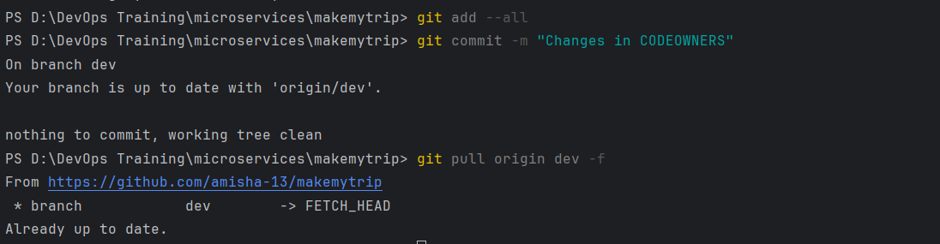

git pull origin dev -f

Forceful push

Mere conflict in differnet file changes

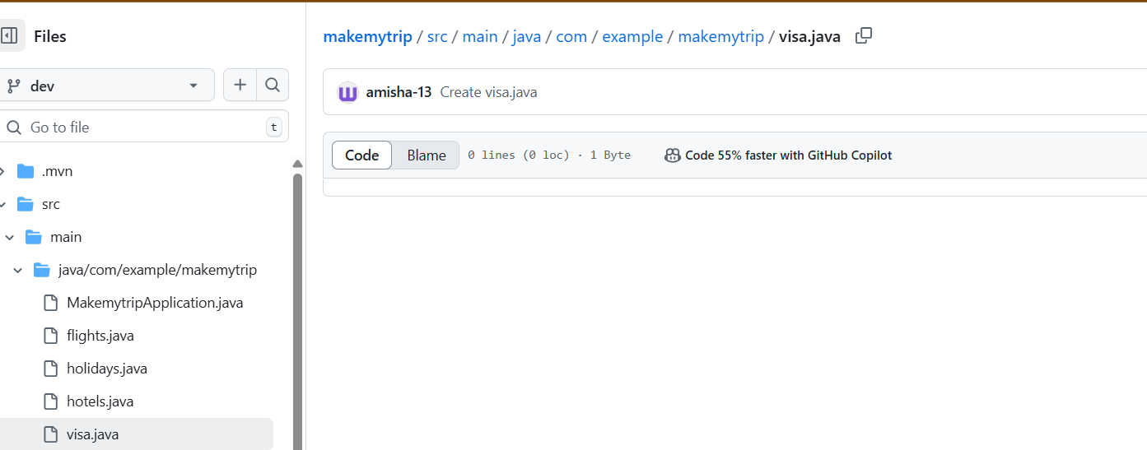

Dev A:

Added changes in visa.java

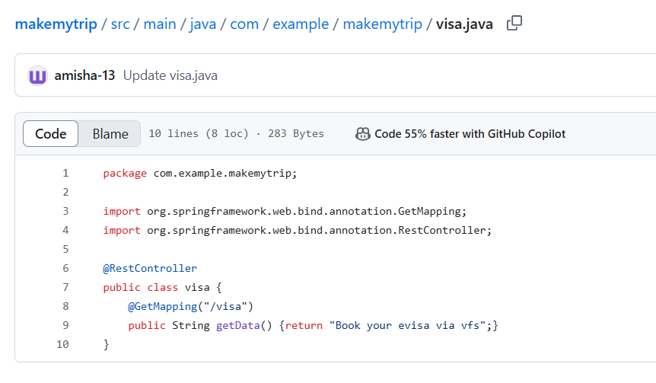

Dev B:

Makes changes in a differnet file: flights.java

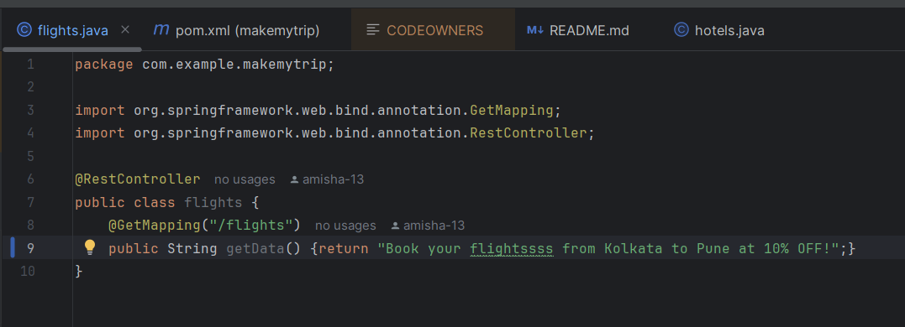

Git status shows my local changes in flights.java file

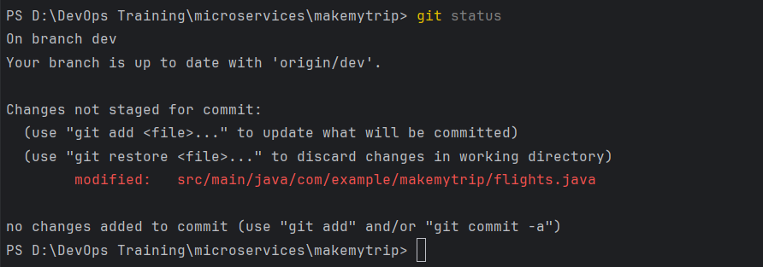

Git A,C,P

Git push origin dev - failed

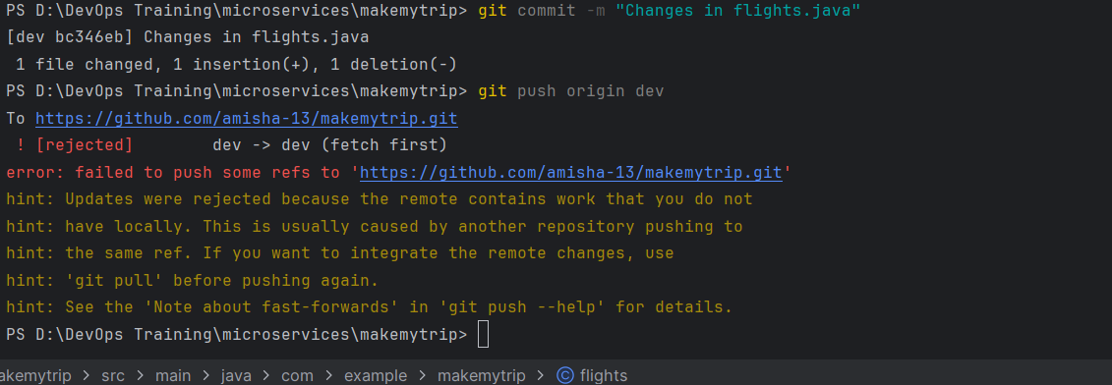

So now git pull origin dev will pull the changes from remote and merge it without an error

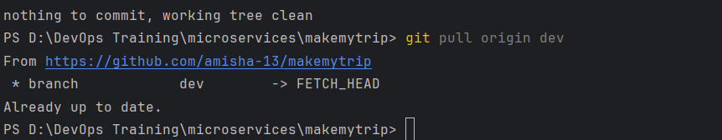

Now since this is java code, we need to maven clean, package

Once that is file you can go ahead and push the changes

> mvn clean package

> git add -all;git commit -m "Changes in flights.java";git push origin dev

Merge conflicts with changes in same files

Dev A:

Made changes in visa.java

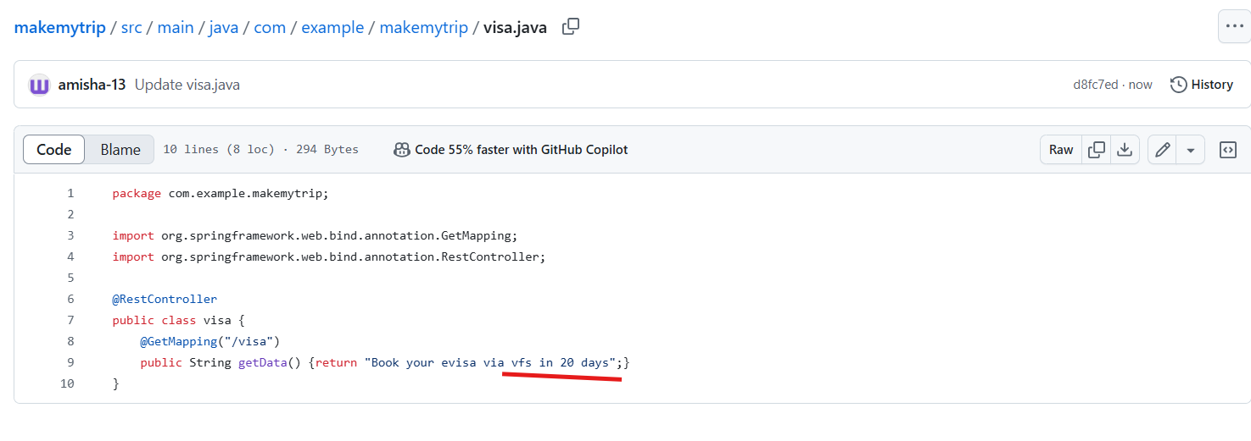

Dev B: Also makes changes in same file but 30 days

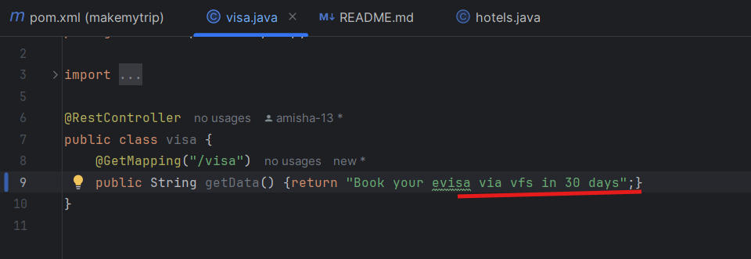

Now git a,c, push: Error out

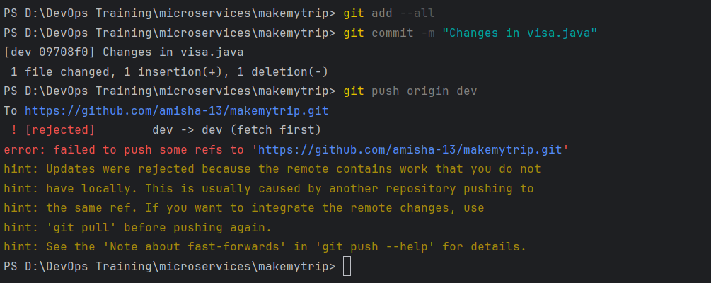

So again we pull the changes as suggested in hint but this time auto merge will fail because changes are in same file

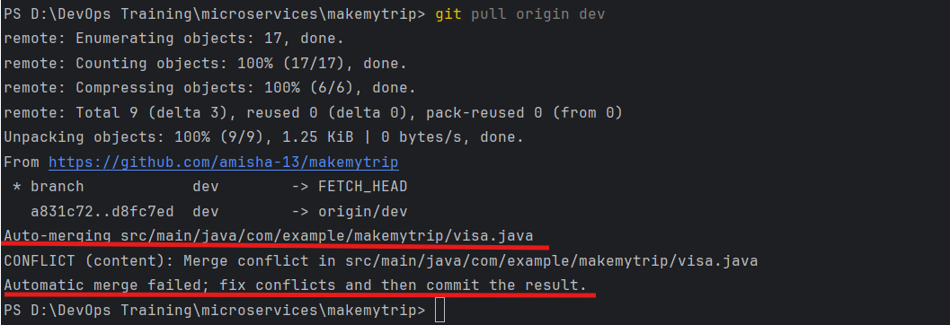

Auto merge is successful - when changes are in different files

Auto merge is failed - when changes are in same files

To resolve failed auto merge:

We can see there are two commits - one is Dev A, other Dev B

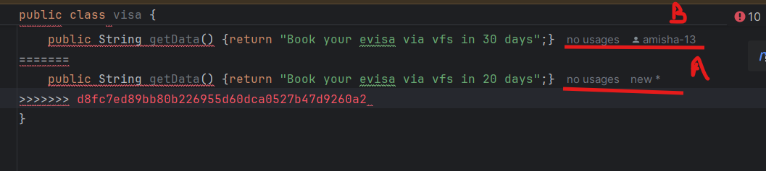

So you need to decide which changes are right according to you and accordingly keep that code and remove the other one

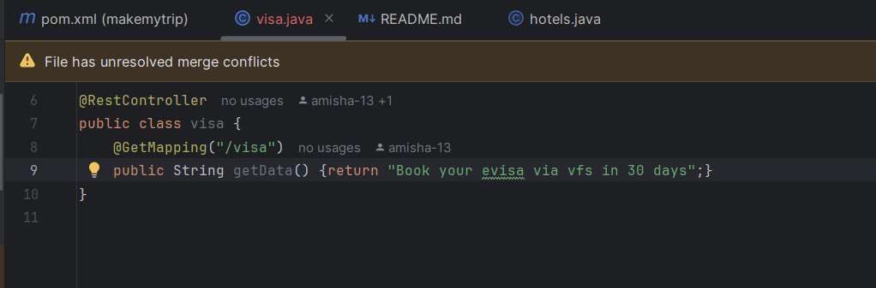

Now maven clean package to have both codes in sync correctly

Once build is successful, git add, commit, push

Now changes are merged

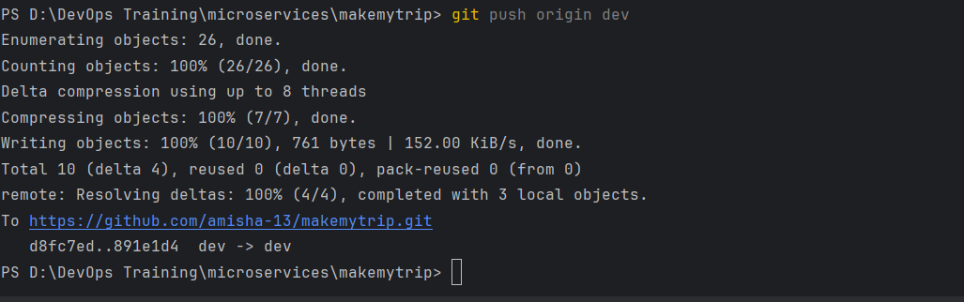

Case 3

git pull origin dev

Same changes both sides right now

Dev 1 made changes in dev branch - visa.java

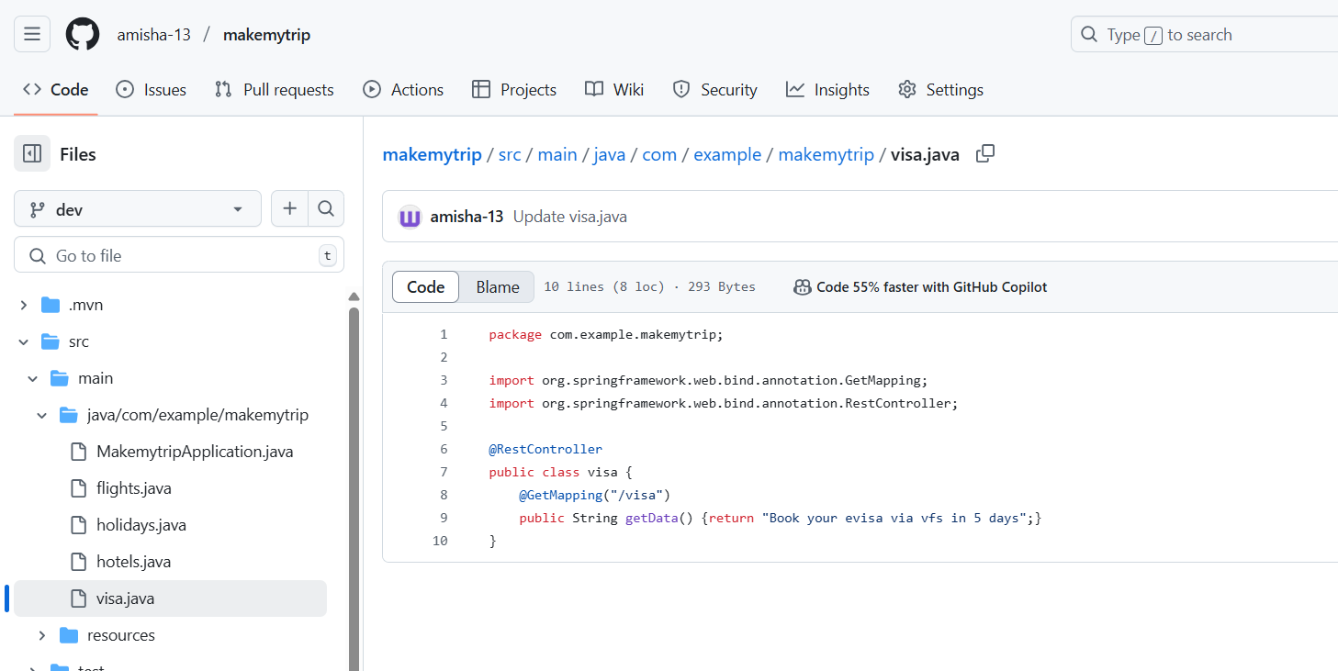

Dev e (myself) dont have this change

I create a new branch

git checkout -b feature/xyz

Then makes changes in visa.java

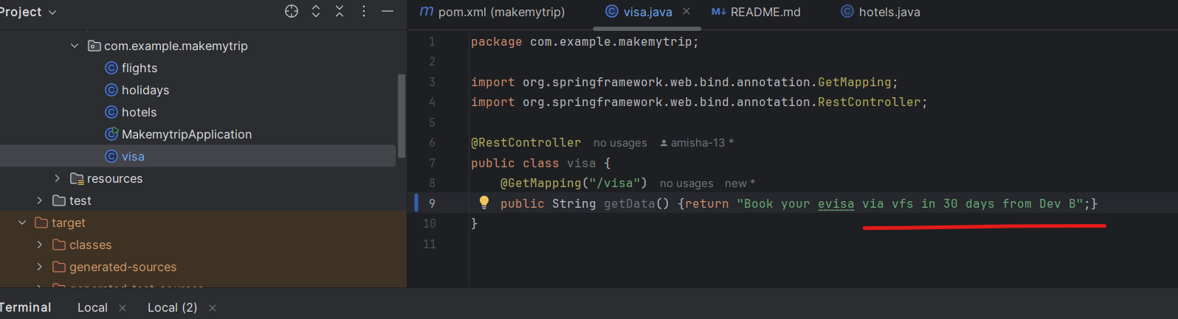

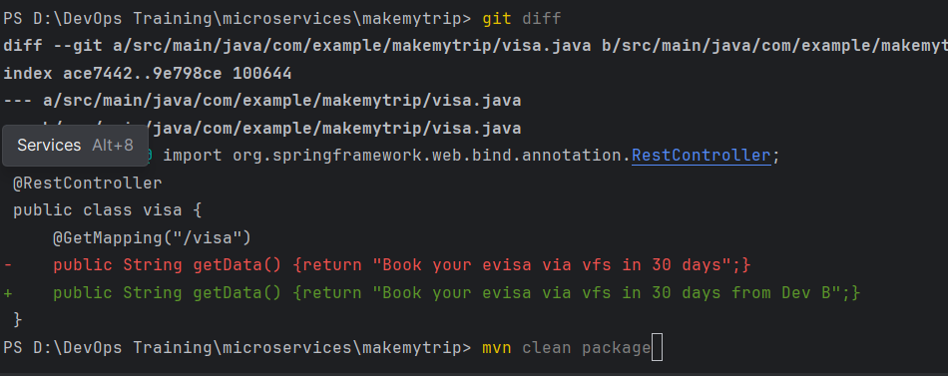

Now maven clean package

Then push code

git add --all;git commit -m "Changes in visa.java by Dev B";git push origin feature/xyz

Open pull request to merge in dev branch

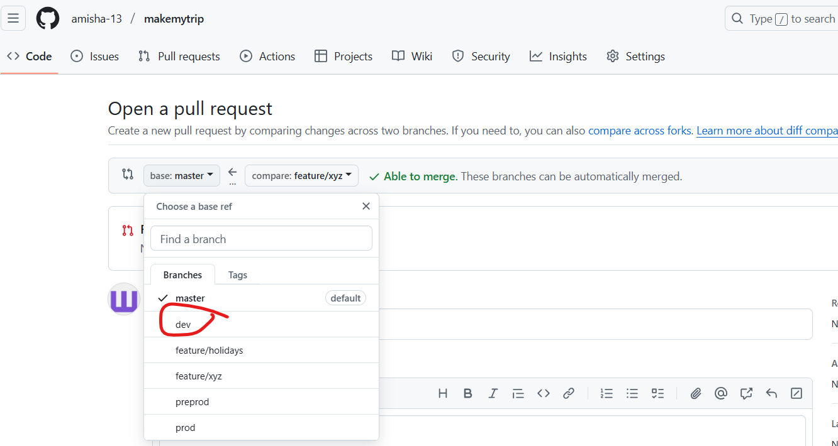

It gives error: that it cannot merge automatically

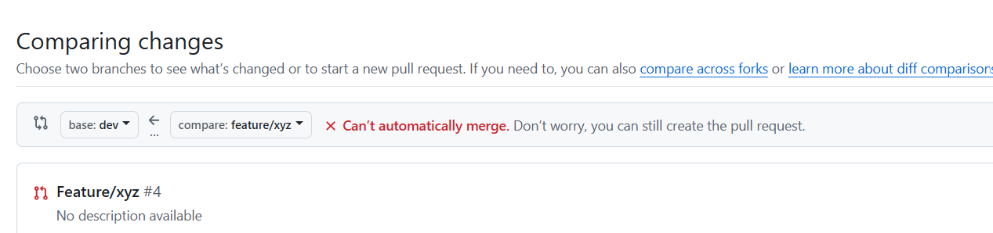

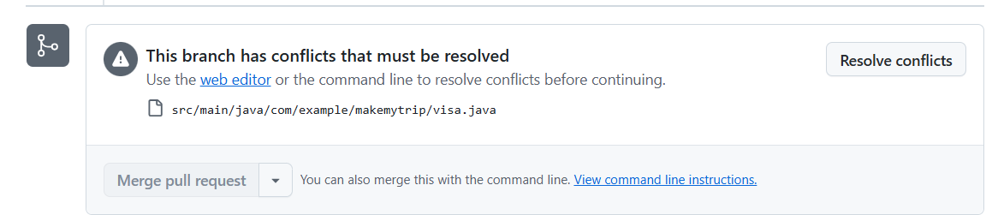

Out of the two branches, dev is the updated one and you need to resolve conflict > click on resolve conflicts

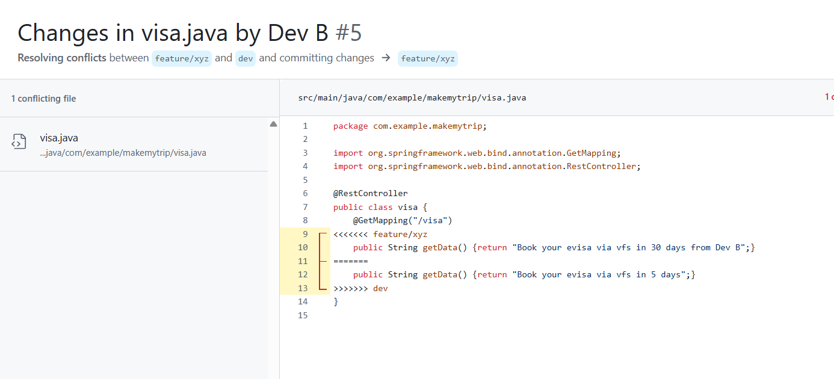

So now we are in branch feature

But we will now pull changes of dev

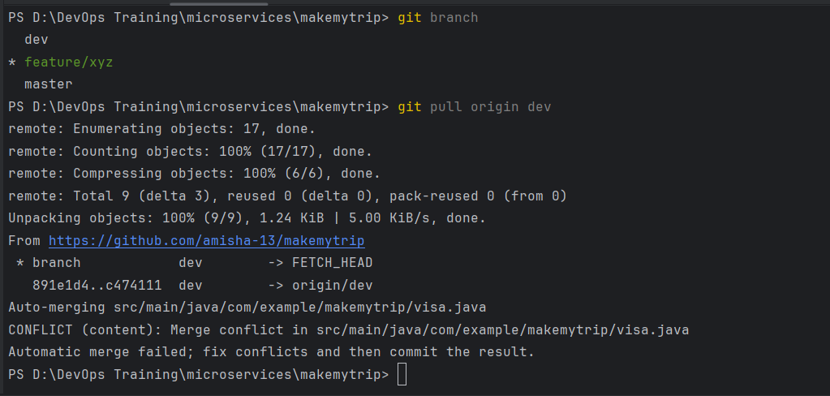

Auto merge is failed so fix it manually now

Chosse which code to keep and run > maven clean package

Then push

WHenever you push for 2nd time you use -f option

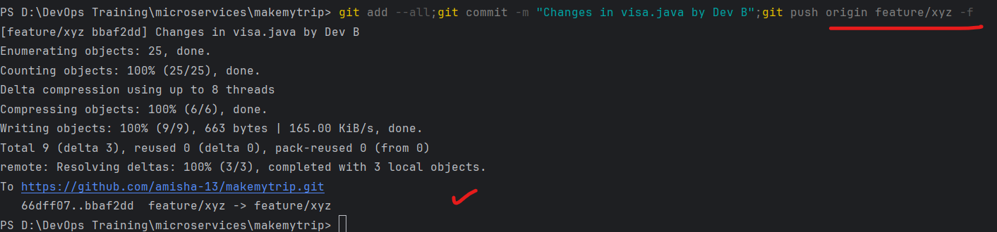

The PR was already created earlier, and now it is updated without error and we have the option to merge

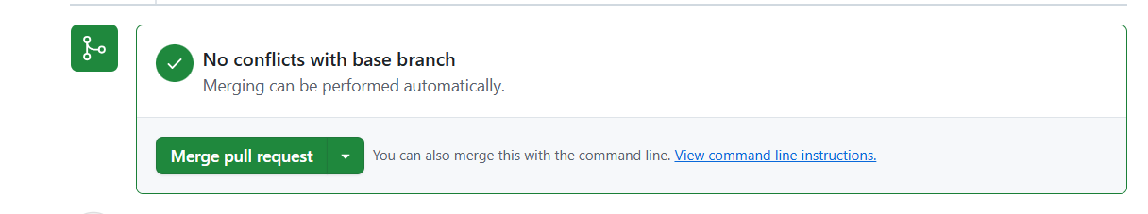

4th May - Day 7

In mumbai region, create Ec2 instance

Name:

AMI: Linux

Instance Type: t2.medium

Create a ey pair - .ppk (downloaded)

Create

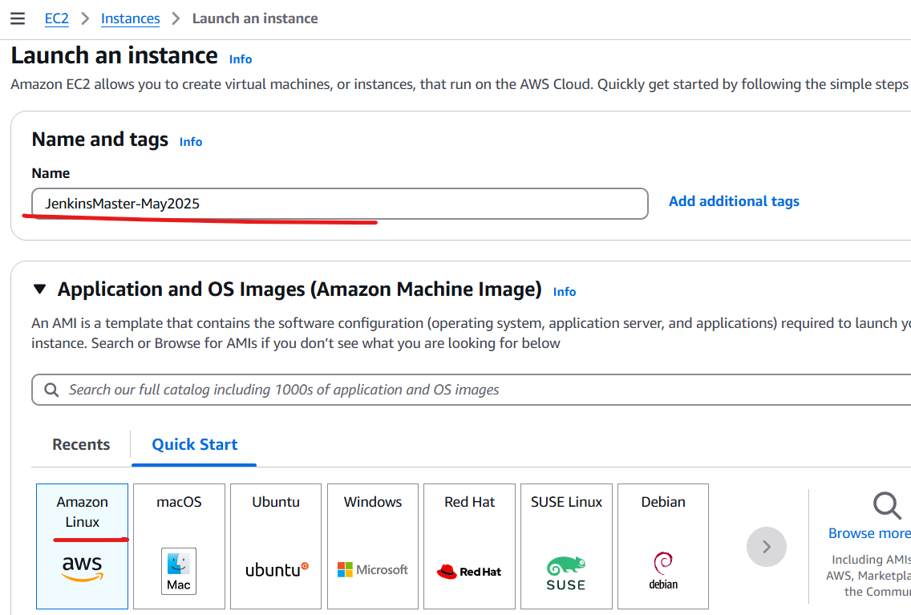

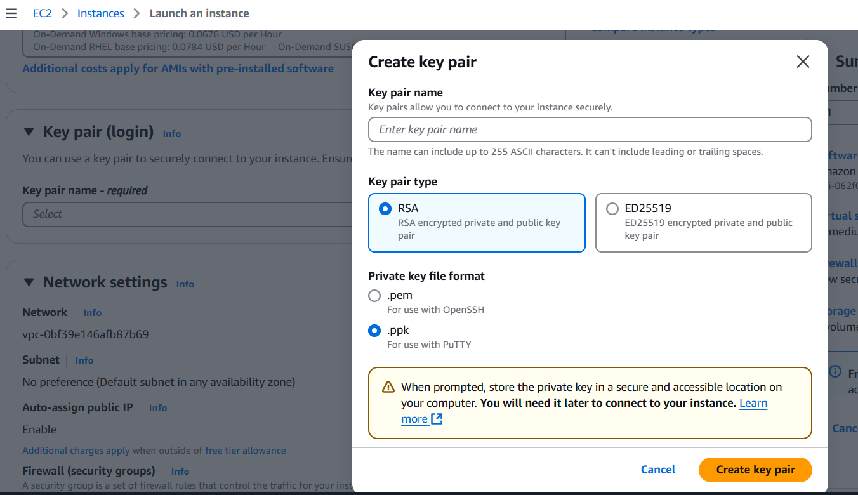

We will connect to server using putty

We need to modify server inbound rules to enable us to connect from anywhere to this machines

Go to security group > edit inbound rules

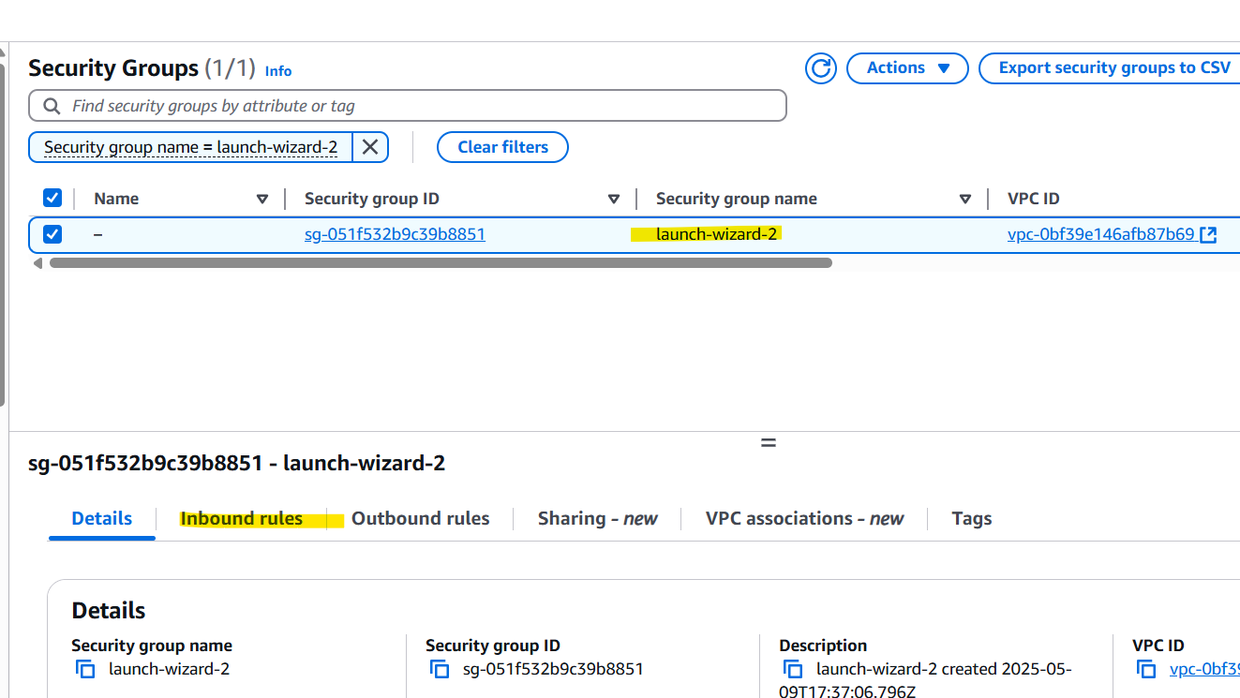

If you select your IP option you can connect only from your machine

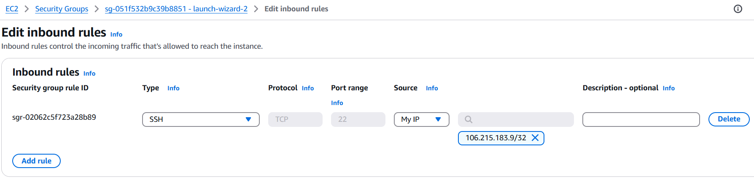

But we need connectivity from anywhere

Also add port 8080 connectivity for tomcat (jenkins)

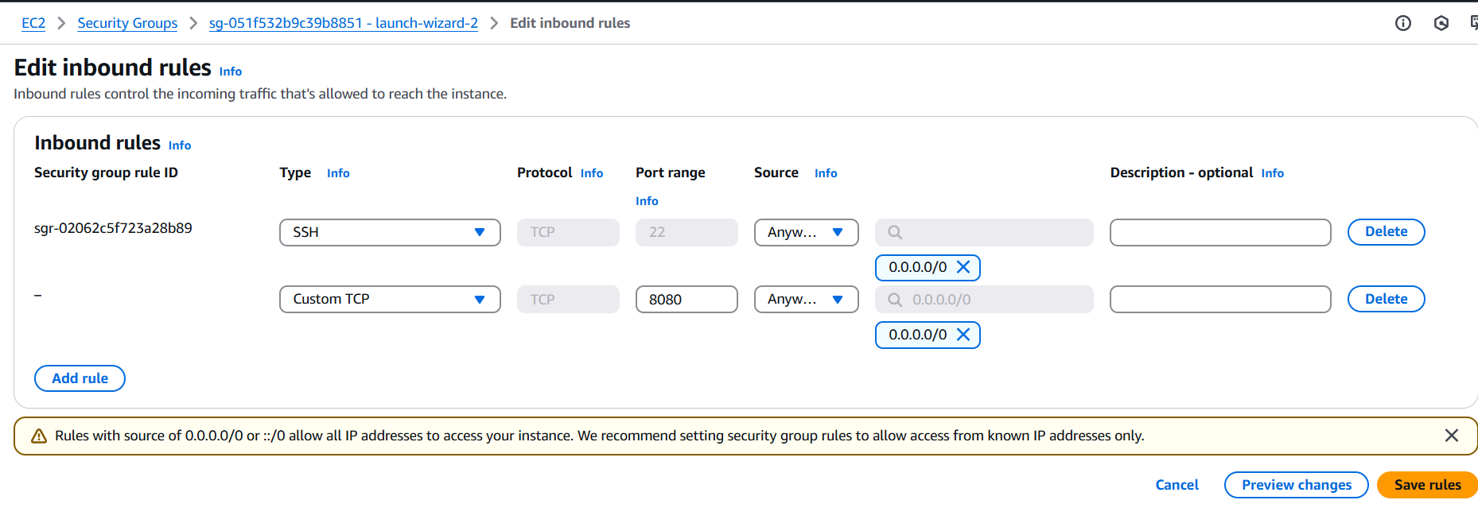

Connect to server using putty

Enter PUBLIC ip address > SSH

Provide the ppk key downloaded

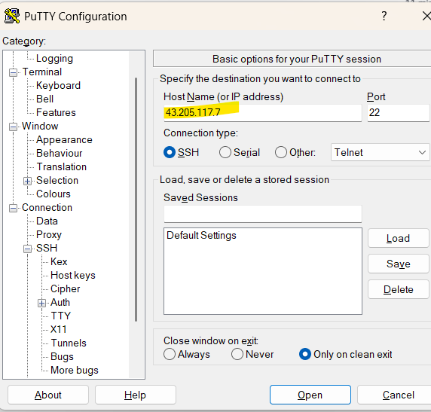

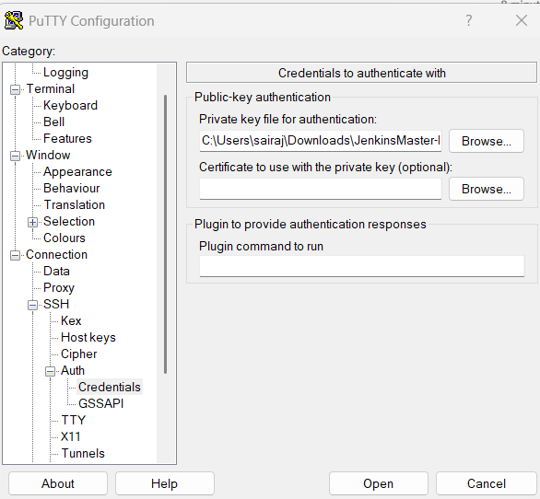

Browse to the .ppk file as private key

Login as ec2-user

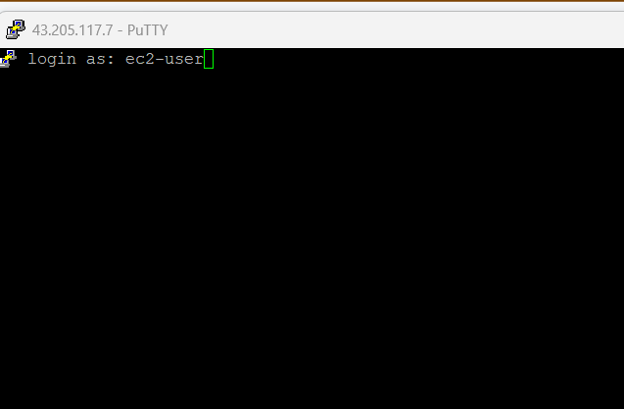

Install the apps

<https://github.com/satyam88/greentea/blob/master/ami>

**sudo su**

Will be running as root user

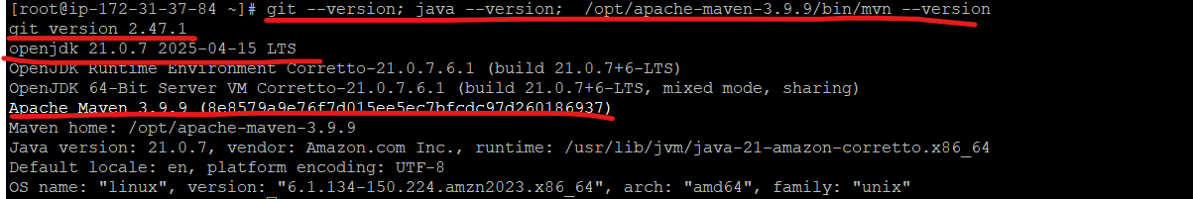

Once all apps are installed, check jenkins status (active)

>service jenkins status

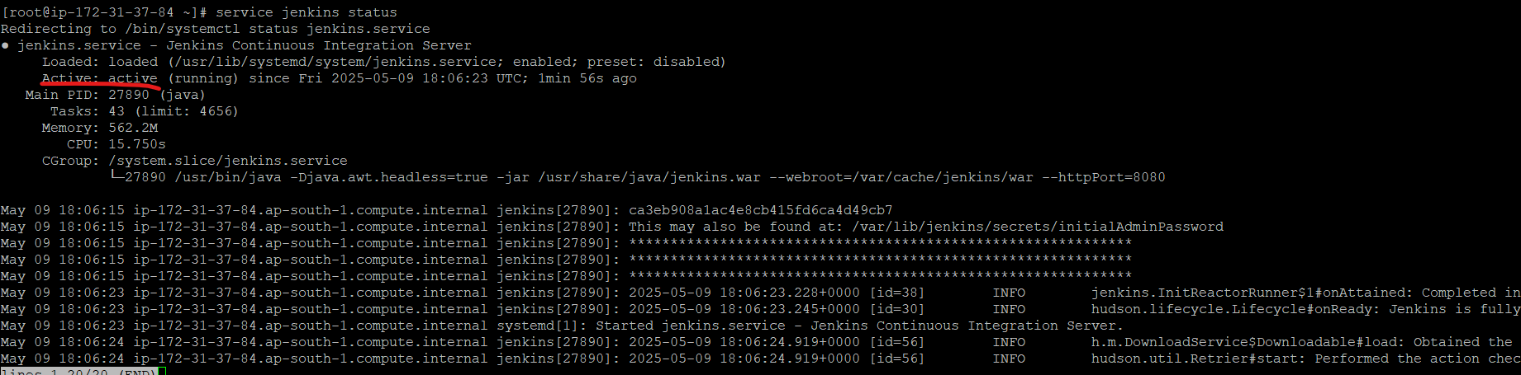

Now access jenkins:

<http://publicip:8080>

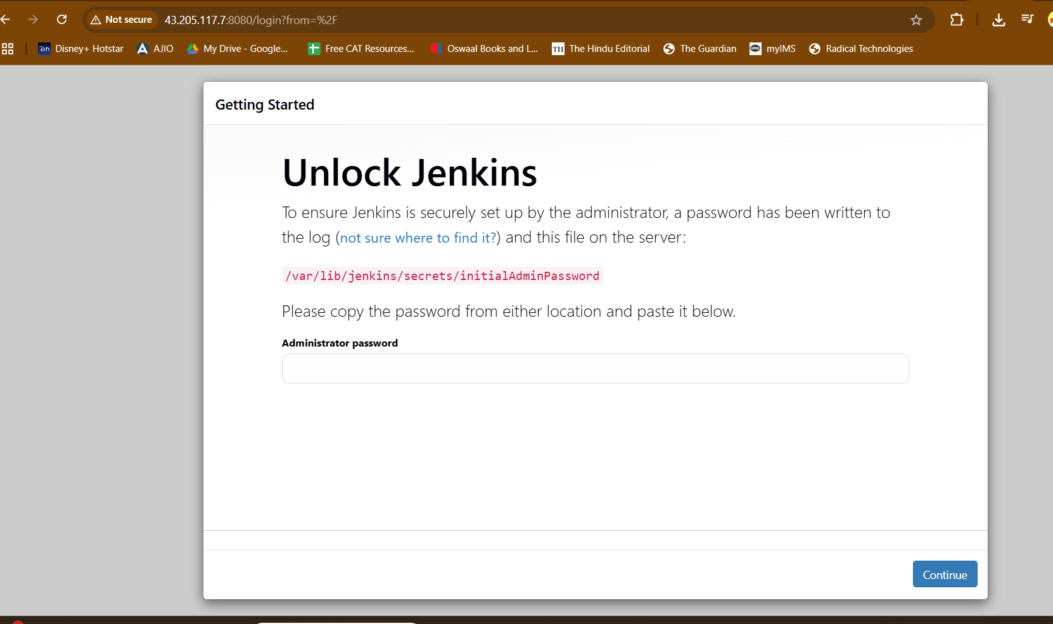

You need this password

So cat this file in screen



Install suggested plugins

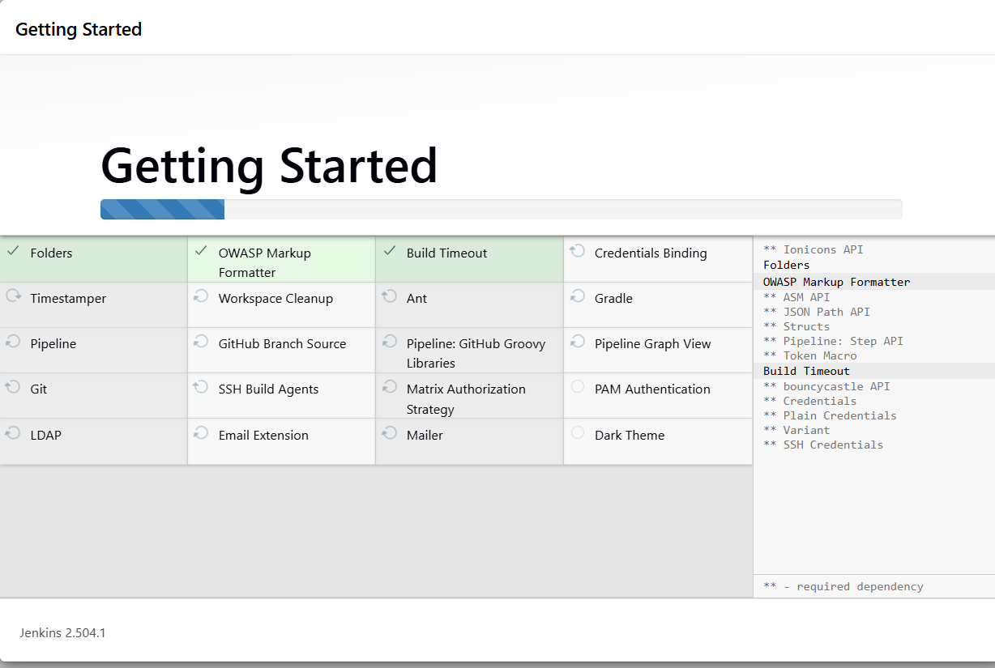

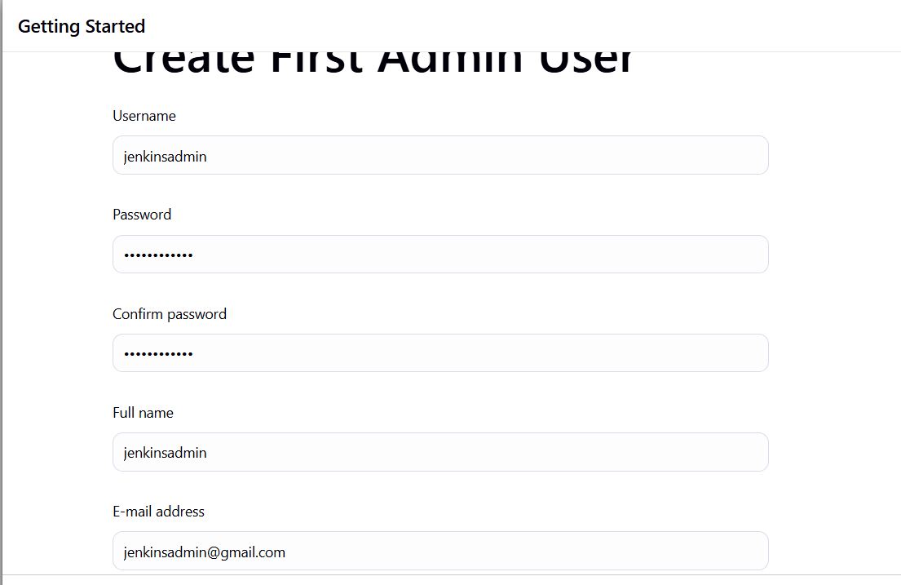

Ping google .com 5 times

[root@ip-172-31-37-84 ~]# ping -c 5 google.com

PING google.com (142.250.199.174) 56(84) bytes of data.

64 bytes from bom07s37-in-f14.1e100.net (142.250.199.174): icmp_seq=1 ttl=114 time=2.70 ms

64 bytes from bom07s37-in-f14.1e100.net (142.250.199.174): icmp_seq=2 ttl=114 time=2.70 ms

64 bytes from bom07s37-in-f14.1e100.net (142.250.199.174): icmp_seq=3 ttl=114 time=2.65 ms

64 bytes from bom07s37-in-f14.1e100.net (142.250.199.174): icmp_seq=4 ttl=114 time=2.36 ms

64 bytes from bom07s37-in-f14.1e100.net (142.250.199.174): icmp_seq=5 ttl=114 time=2.61 ms

--- google.com ping statistics ---

5 packets transmitted, 5 received, 0% packet loss, time 4007ms

rtt min/avg/max/mdev = 2.359/2.604/2.702/0.127 ms

[root@ip-172-31-37-84 ~]#

[root@ip-172-31-37-84 ~]#

[root@ip-172-31-37-84 ~]#

[root@ip-172-31-37-84 ~]#

[root@ip-172-31-37-84 ~]# ping -c 5 google.com > /tmp/google.txt

[root@ip-172-31-37-84 ~]# cat /tmp/google.txt

PING google.com (142.250.192.142) 56(84) bytes of data.

64 bytes from bom12s18-in-f14.1e100.net (142.250.192.142): icmp_seq=1 ttl=114 time=2.16 ms

64 bytes from bom12s18-in-f14.1e100.net (142.250.192.142): icmp_seq=2 ttl=114 time=2.47 ms

64 bytes from bom12s18-in-f14.1e100.net (142.250.192.142): icmp_seq=3 ttl=114 time=1.94 ms

64 bytes from bom12s18-in-f14.1e100.net (142.250.192.142): icmp_seq=4 ttl=114 time=1.89 ms

64 bytes from bom12s18-in-f14.1e100.net (142.250.192.142): icmp_seq=5 ttl=114 time=2.28 ms

--- google.com ping statistics ---

5 packets transmitted, 5 received, 0% packet loss, time 4006ms

rtt min/avg/max/mdev = 1.892/2.149/2.473/0.215 ms

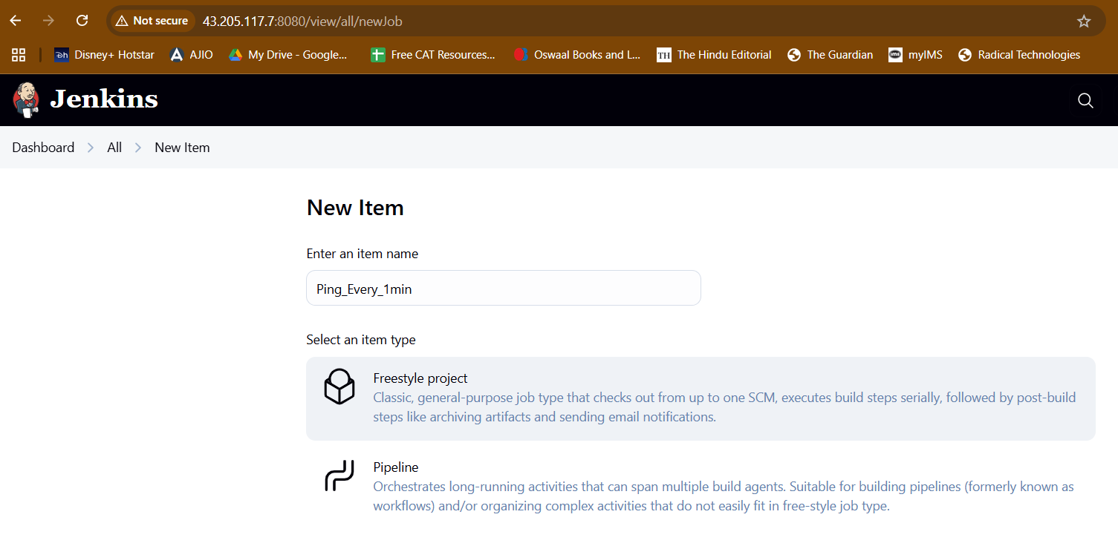

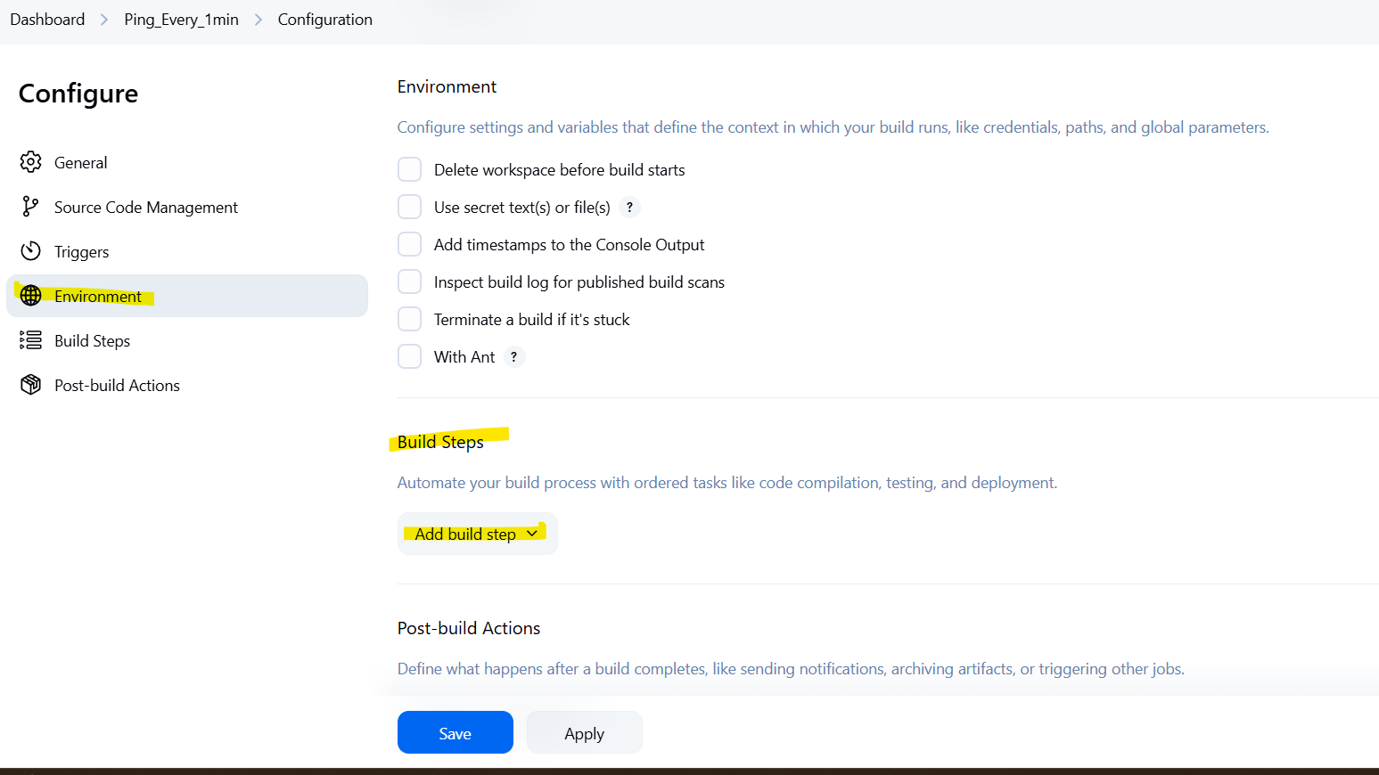

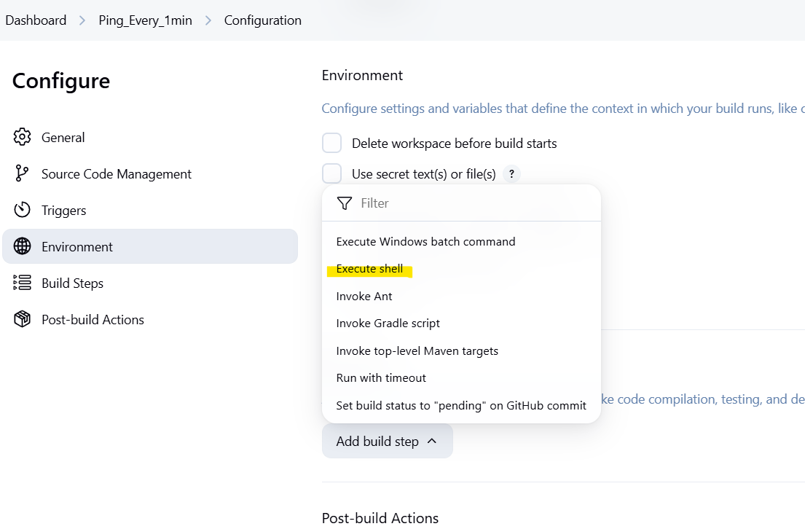

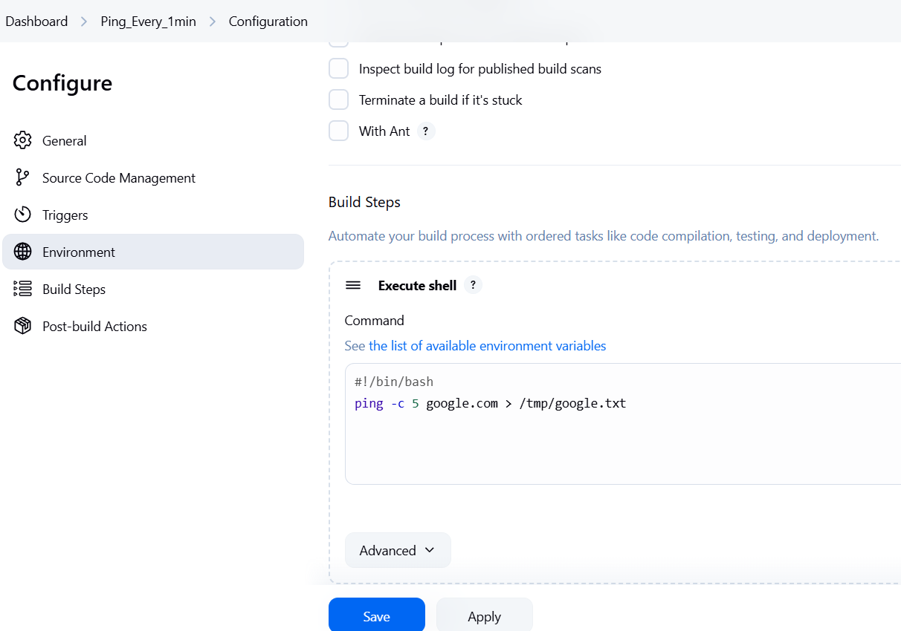

Build steps > execute shell

Add:

#!/bin/bash

This line is compulsory

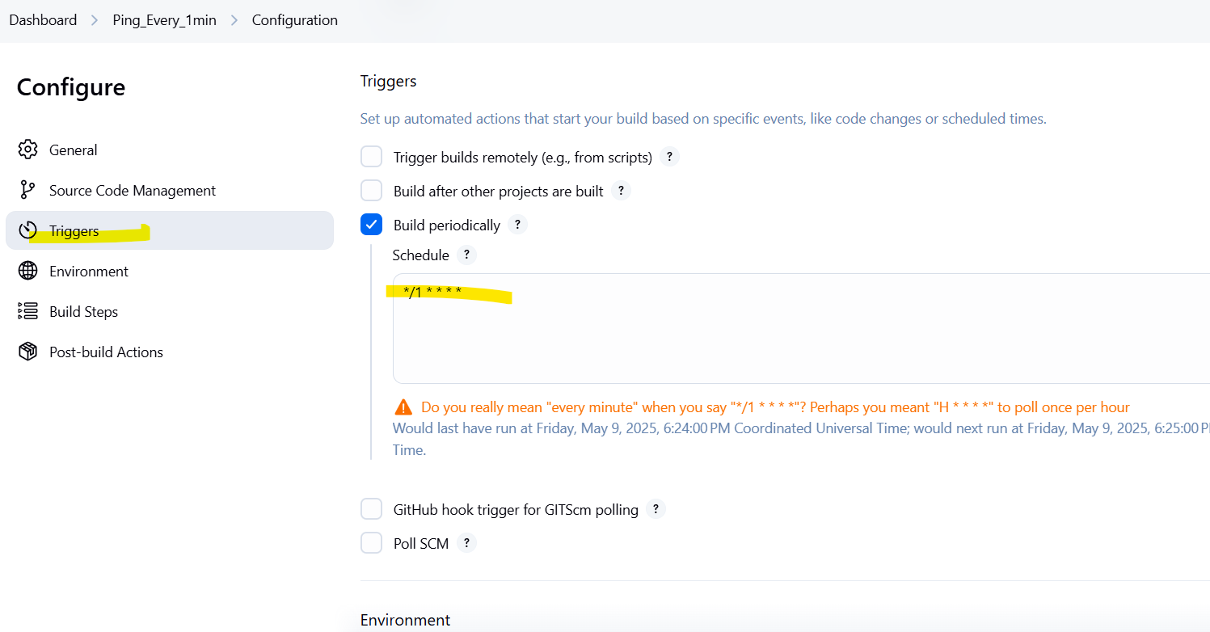

Also add trigger to run it every minute

*/1 * * * *

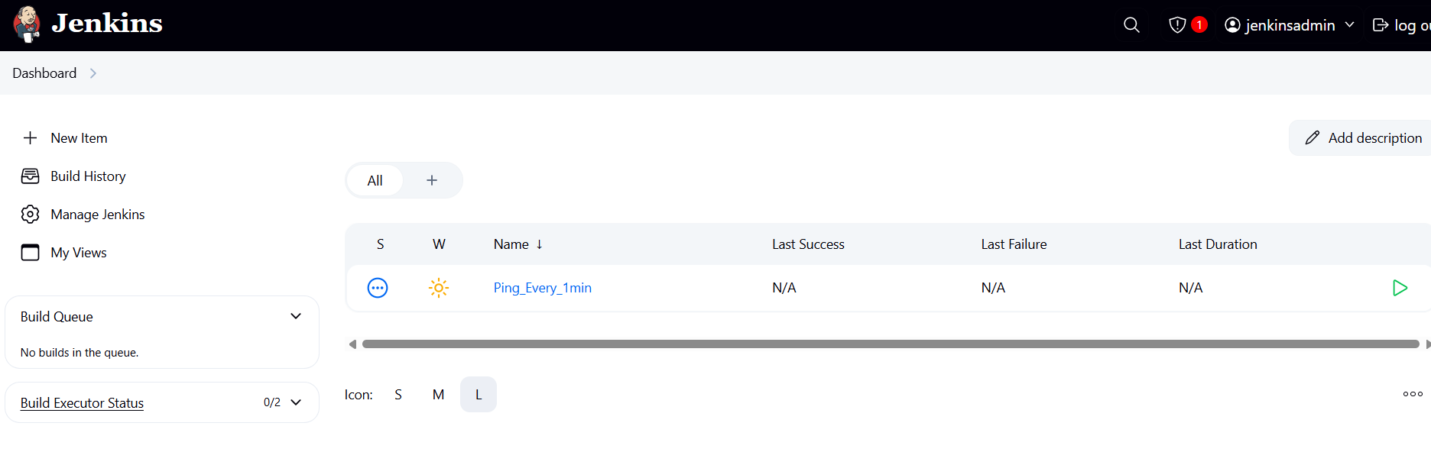

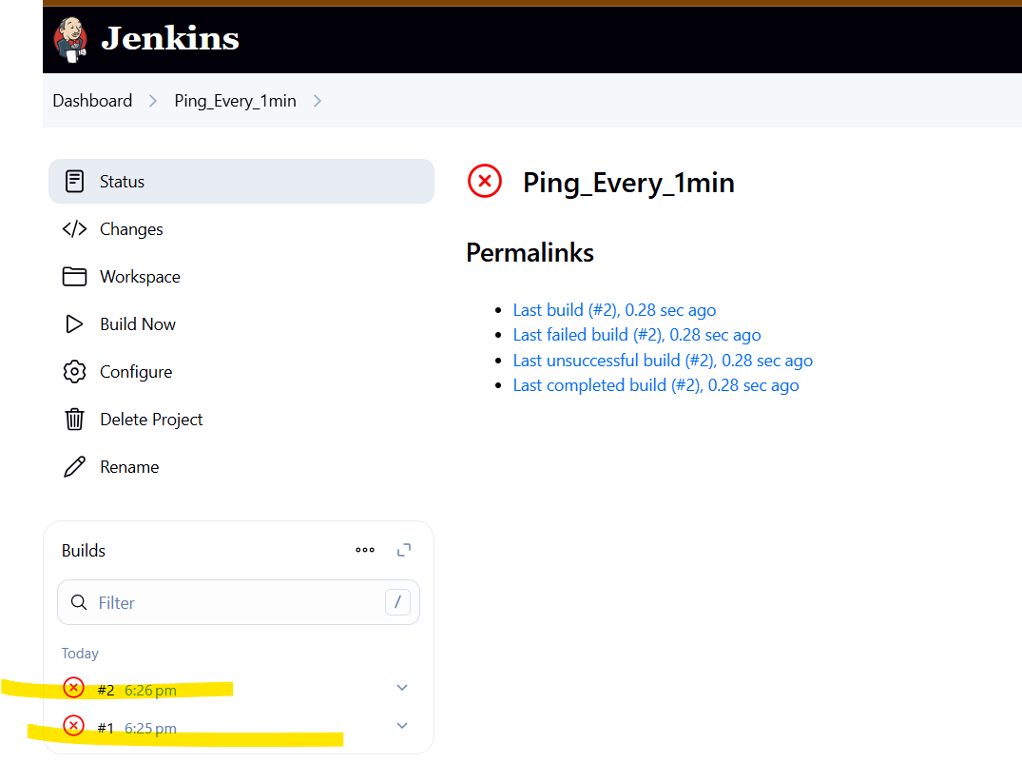

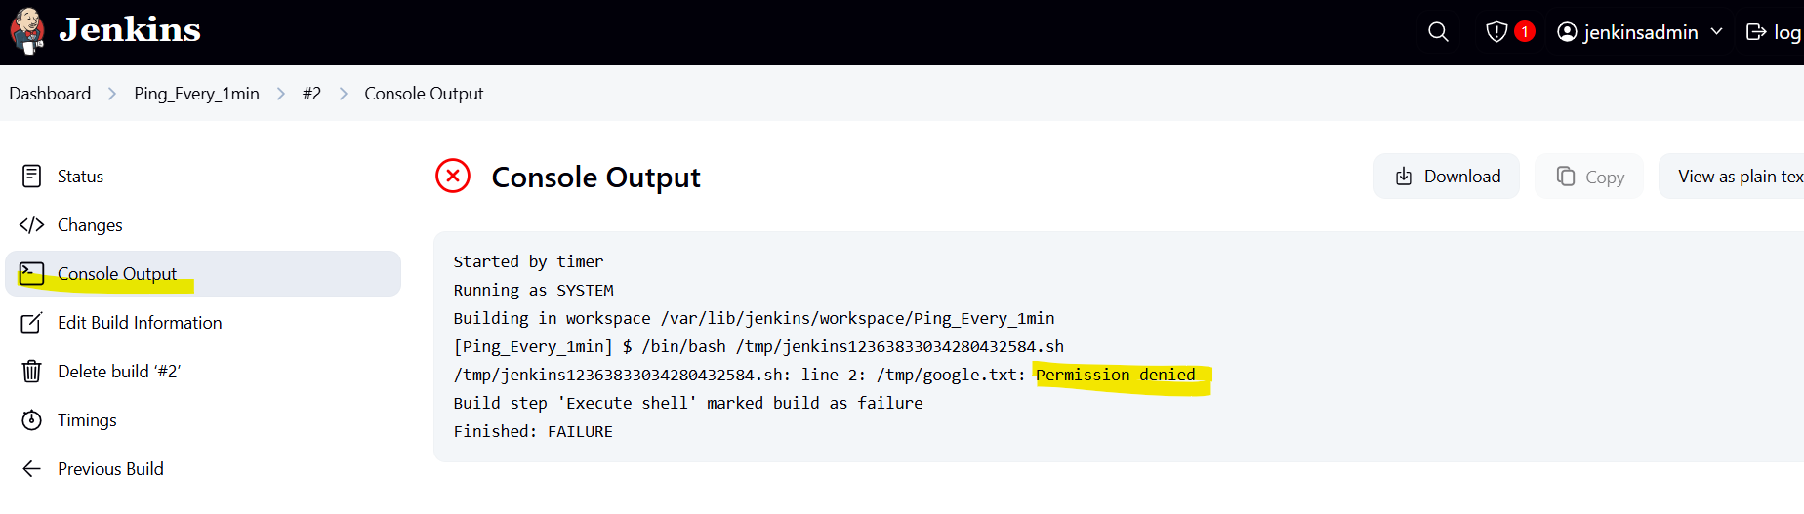

Jenkins user has no permission to this file

[root@ip-172-31-37-84 ~]# ls -ld /tmp/google.txt

-rw-r--r--. 1 root root 660 May 9 18:19 /tmp/google.txt

Oly root user has access to this file

Add entry of jenkins user

> visudo

To edit permissions

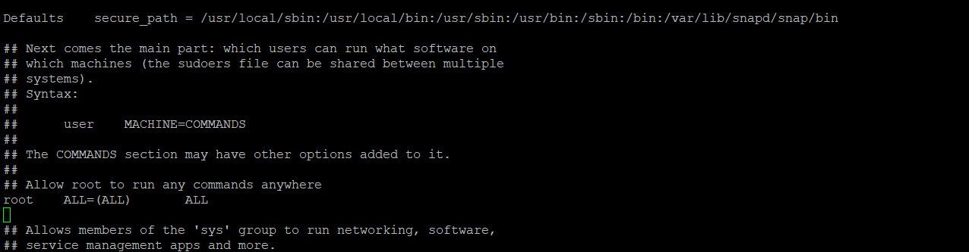

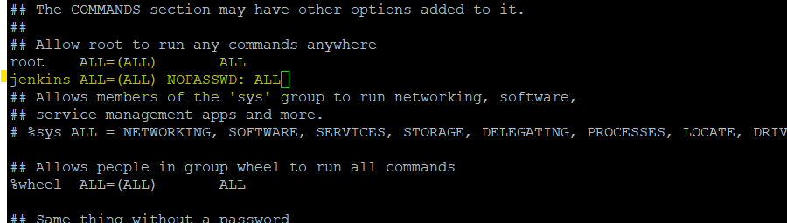

This gives jenkins root permissions

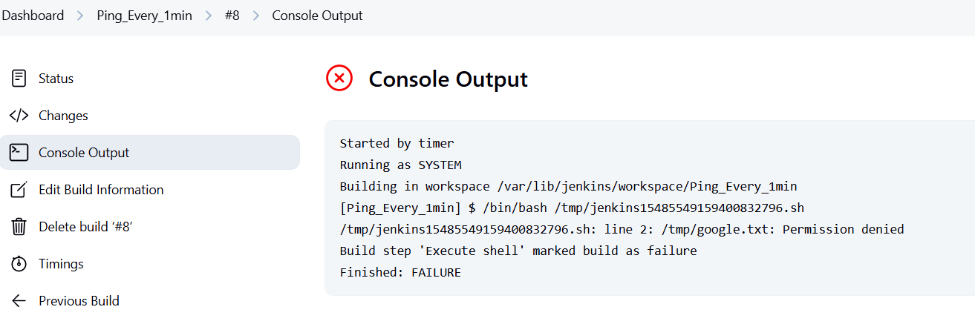

File owner is still root user

So change owner -

[root@ip-172-31-37-84 ~]# chown jenkins:jenkins /tmp/google.txt

[root@ip-172-31-37-84 ~]# chmod 755 /tmp/google.txt

> ls -ld /tmp/google.txt



Now jenkins is the owner of this file

Now job is successful -

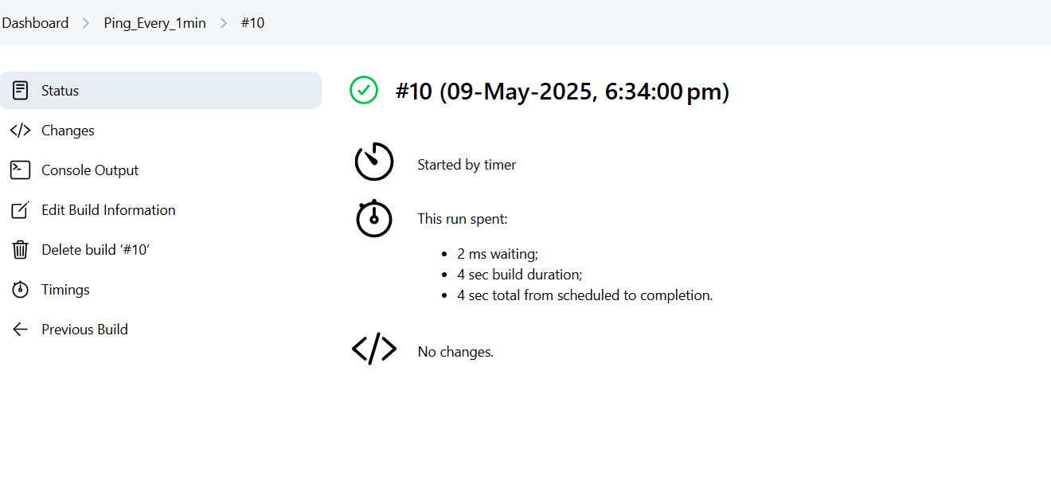

Flowing output

tail -f /tmp/google.txt

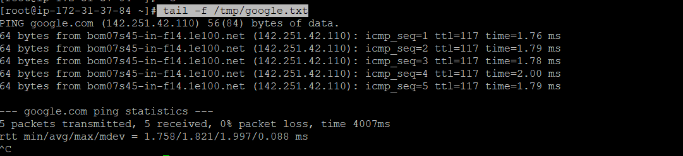

Change the job using configure option

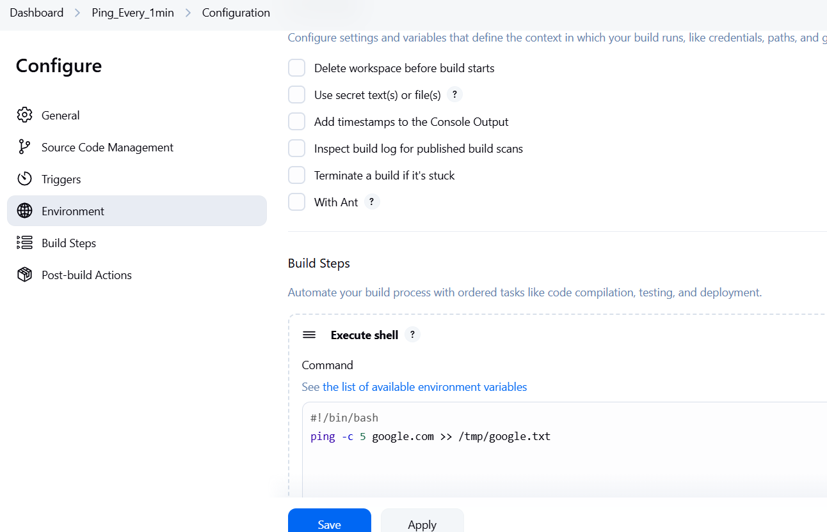

If yu put > arrow - it will replace the output

If you put >> - it will append the output

[root@ip-172-31-37-84 ~]# java --version

openjdk 21.0.7 2025-04-15 LTS

OpenJDK Runtime Environment Corretto-21.0.7.6.1 (build 21.0.7+6-LTS)

OpenJDK 64-Bit Server VM Corretto-21.0.7.6.1 (build 21.0.7+6-LTS, mixed mode, sharing)

[root@ip-172-31-37-84 ~]# which java

/usr/bin/java

[root@ip-172-31-37-84 ~]# readlink -f /usr/bin/java

/usr/lib/jvm/java-21-amazon-corretto.x86_64/bin/java

[root@ip-172-31-37-84 ~]# cd /usr/lib/jvm/java-21-amazon-corretto.x86_64/

[root@ip-172-31-37-84 java-21-amazon-corretto.x86_64]# ls -ltr

total 52

-rw-r--r--. 1 root root 1244 Apr 10 18:06 release

drwxr-xr-x. 71 root root 16384 May 9 18:03 legal

drwxr-xr-x. 3 root root 18 May 9 18:04 man

drwxr-xr-x. 5 root root 146 May 9 18:04 conf

drwxr-xr-x. 5 root root 16384 May 9 18:04 lib

drwxr-xr-x. 3 root root 132 May 9 18:04 include

drwxr-xr-x. 2 root root 16384 May 9 18:04 bin

[root@ip-172-31-37-84 java-21-amazon-corretto.x86_64]# which git

/usr/bin/git

[root@ip-172-31-37-84 java-21-amazon-corretto.x86_64]# echo $M2_HOME

/opt/apache-maven-3.9.9

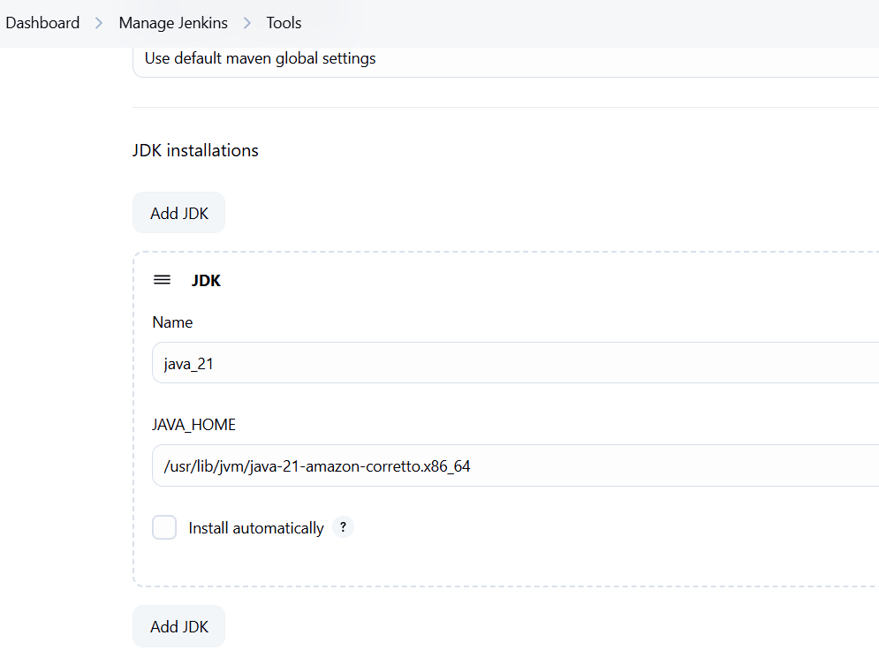

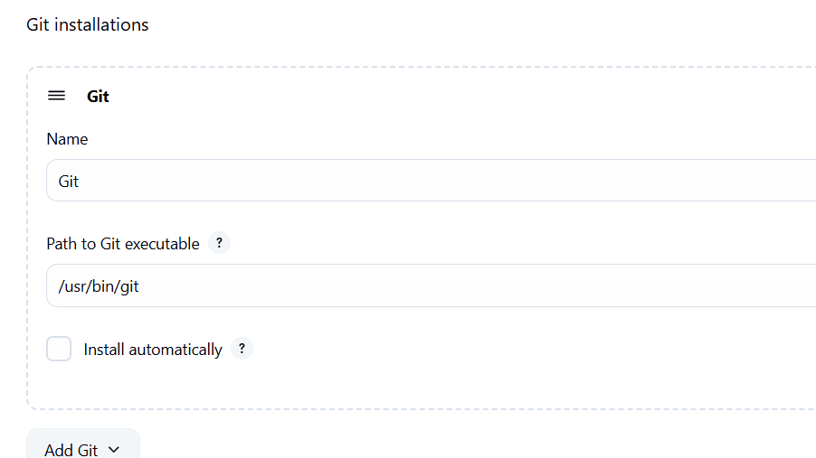

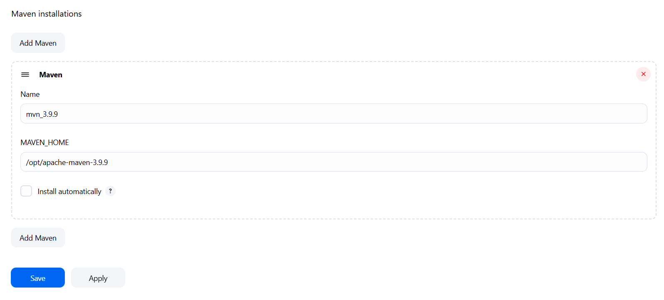

Add java, git and maven paths on jenkins